

A.C.S Nagar(Irumbedu), Arni,

T.V.Malai Dt.-632 317.



# 

*Department*

*Of*

*Information Technology*

**CCS335-Cloud Computing Laboratory**





A.C.S Nagar(Irumbedu), Arni, T.V.Malai Dt.-632 317.

***Department***

***of***

***Information Technology***

BONAFIDE CERTIFICATE

*Certified that this is a bonafide record of work done by*

*Of Third Year / V Semester* ***B.Tech Information Technology*** *in the Anna University Practical Examination during the year* ***20 - 20*** *in* ***CCS335 Cloud Computing Laboratory.***

Register No. :

|  |  |  |  |  |  |  |  |  |  |  |  |
| --- | --- | --- | --- | --- | --- | --- | --- | --- | --- | --- | --- |
|  |  |  |  |  |  |  |  |  |  |  |  |

Staff In-Charge Head of the Department

Submitted for Practical Examination held on

Internal Examiner External Examiner

INDEX

|  |  |  |  |  |
| --- | --- | --- | --- | --- |
| **S.NO** | **Date** | **Title** | **Page Number** | **Signature** |
| 1 |  | Install Virtualbox/VMware/ Equivalent open source cloud Workstation with different flavours of Linux or Windows OS on top of windows 8 and above. |  |  |
| 2 |  | Install a C compiler in the virtual machine created using a virtual box and execute Simple Programs. |  |  |
| 3 |  | Install Google App Engine. Create a hello world app and other simple web applications using python/java. |  |  |
| 4 |  | Use the GAE launcher to launch the web applications. |  |  |
| 5 |  | Simulate a cloud scenario using CloudSim and run a scheduling algorithm that is not present in CloudSim. |  |  |
| 6 |  | Find a procedure to transfer the files from one virtual machine to another virtual machine. |  |  |
| 7 |  | Install Hadoop single node cluster and run simple applications like wordcount. |  |  |
| 8 |  | Creating and Executing Your First Container Using Docker. |  |  |
| 9 |  | Run a Container from Docker Hub. |  |  |

|  |  |
| --- | --- |
| **EX.NO: 1**  **DATE:** | Install Virtualbox/VMware/ Equivalent open source cloud Workstation with different flavours of Linux or Windows OS on top of windows 8 and above. |

**Introduction**

## Virtualization:

* + Virtualization is the creation of virtual servers, infrastructures, devices and computing resources.
  + Virtualization changes the hardware-software relations and is one of the foundational elements of cloud computing technology that helps utilize the capabilities of cloud computing to the full.
  + Virtualization techniques allow companies to turn virtual their networks, storage, servers, data, desktops and applications.

## Hypervisor or Virtual Machine Monitor (VMM)

A **hypervisor** or **virtual machine monitor** (**VMM**) is a piece of computer software, firmware or hardware that creates and runs virtual machines. A computer on which a hypervisor is running one or more virtual machines is defined as a *host machine*. Each virtual machine is called a *guest machine*. The hypervisor presents the guest operating systems with a virtual operating platform and manages the execution of the guest operating systems. Multiple instances of a variety of operating systems may share the virtualized hardware resources.

## Types of Virtualization

* + **Operating-system-level virtualization -** is a server-virtualization method where the kernel of an operating system allows for multiple isolated user- space instances, instead of just one. Such instances (sometimes called **containers**, **software containers**,[1] virtualization engines (VE), virtual private servers (VPS), or jails) may look and feel like a real server from the point of view of its owners and users
  + **Platform / Hardware virtualization -**Hardware virtualization or platform virtualization refers to the creation of a virtual machine that acts like a real computer with an operating system. Software executed on these virtual machines is separated from the underlying hardware resources. For example, a computer that is

running Microsoft Windows may host a virtual machine that looks

like a computer with the Ubuntu Linux operating system; Ubuntu- based software can be run on the virtual machine.

* + **In hardware virtualization**, the host machine is the actual machine on which the virtualization takes place, and the guest machine is the virtual machine. The words *host* and *guest* are used to distinguish the software that runs on the physical machine from the software that runs on the virtual machine. Different types of **Full virtualization**: Almost complete simulation of the actual hardware to allow software, which typically consists of a guest operating system, to run unmodified.
* **Partial virtualization**: Some but not all of the target environment is simulated. Some guest programs, therefore, may need modifications to run in this virtual environment.
* **Para virtualization**: A hardware environment is not simulated; however, the guest programs are executed in their own isolated domains, as if they are running on a separate system.
* **Application virtualization** is software technology that encapsulates computer programs from the underlying operating system on which it is executed. A fully virtualized application is not installed in the traditional sense, although it is still executed as if it were.

## Oracle Virtualbox

o VirtualBox is a general-purpose full virtualizer for x86 hardware, targeted at server, desktop and embedded use.Each virtual machine can execute its own operating system, including versions of Microsoft Windows, Linux, BSD, and MS-DOS. VMware Workstation is developed and sold by VMware, Inc., a division of EMCCorporation

## Ubuntu

o Ubuntu is an operating system like any other and it is free & open source. It means that we can download it freely and install on as many computers as we like. By the term open source it means that we can actually see its code. To provide a more secure environment, the ―SUDO‖ tool is used to assign temporary privileges for performing administrative tasks. Ubuntu comes installed with a wide range of Software that includes Libre Office ,Firefox, Thunderbird

## Steps in Installing Oracle Virtualbox with CentOS 7 Step1:

Download and Install Oracle Virtual Box latest version & Extension package

* + <https://virtualbox.org/wiki/downloads>

Step 2:

* Download CentOS 7 OVA(Open Virtual Appliance) from

Link : <https://linuxvmimages.com/images/centos-7>

**Step 3:** The files are downloaded in your Local machine and Click the Oracle VM VirtualBox 6.0.8 Setup Wizard

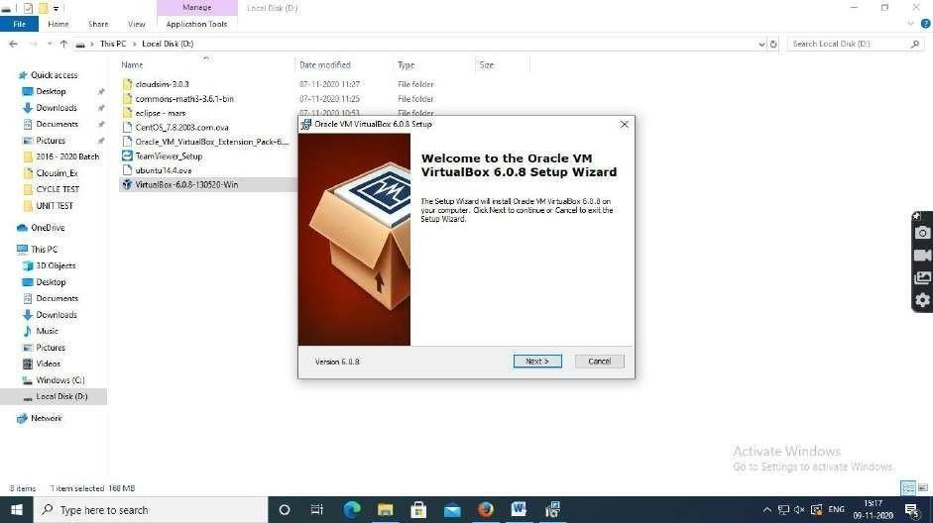

## Oracle VM VirtualBox 6.0.8 Setup Wizard is open and follows the steps to install

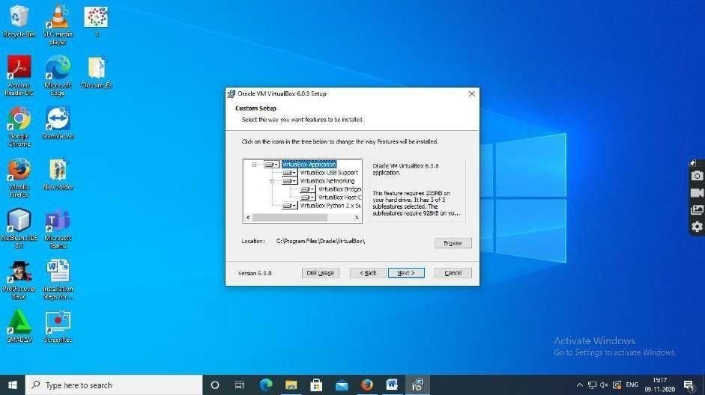

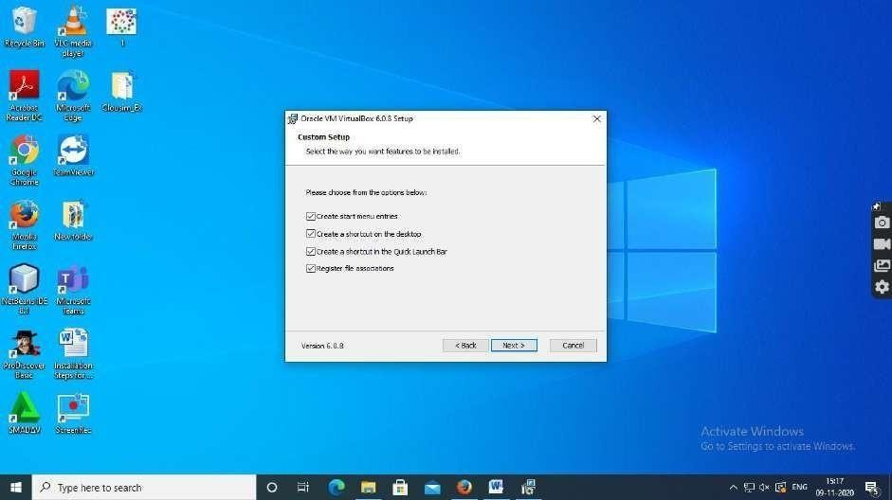

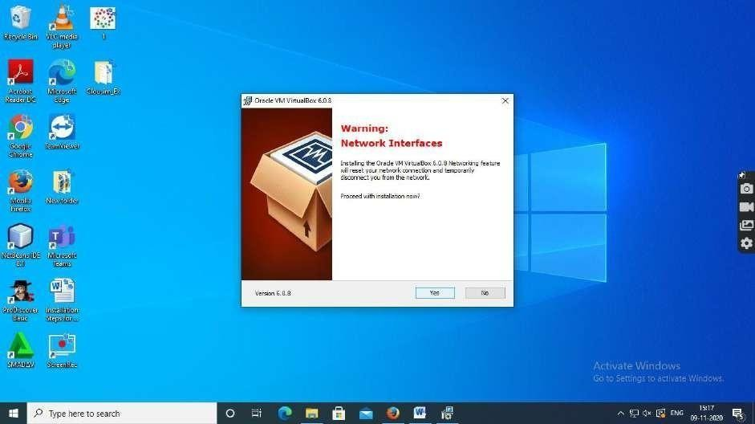

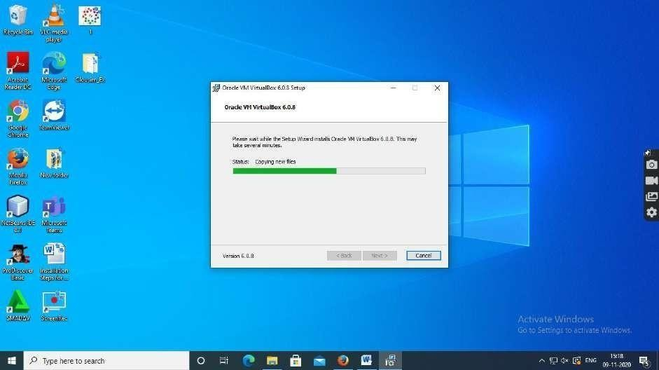

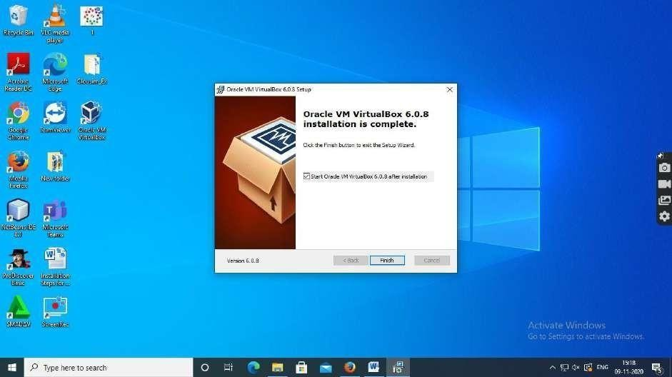

**Oracle VM VirtualBox 6.0.8 installation is complete**

**Step 4:** Import the Oracle VM Virtual Extension pack into the Oracle Virtual Box

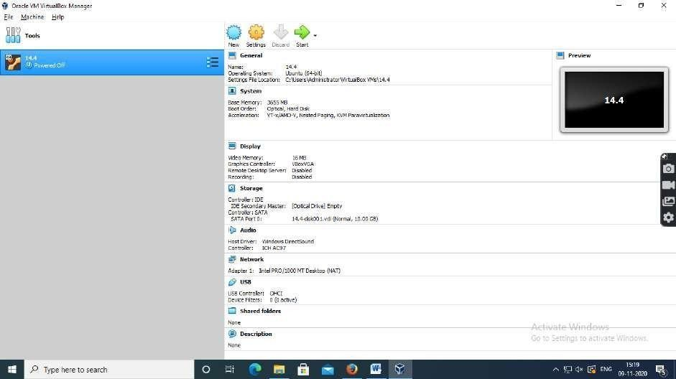

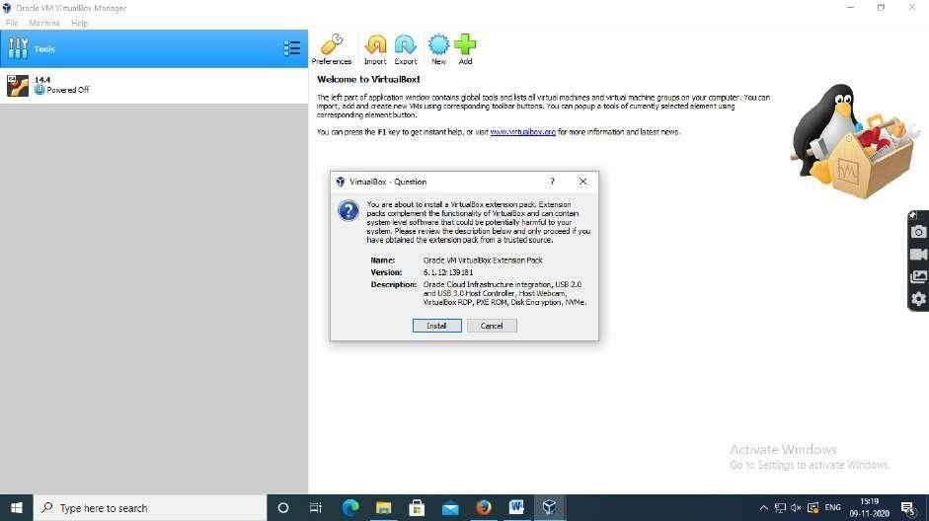

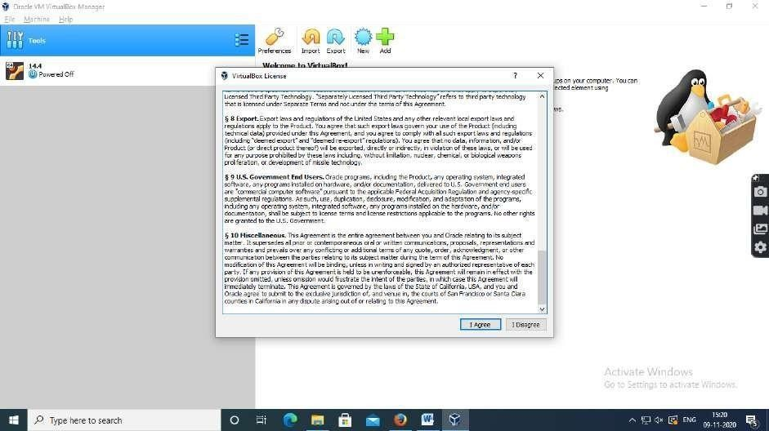

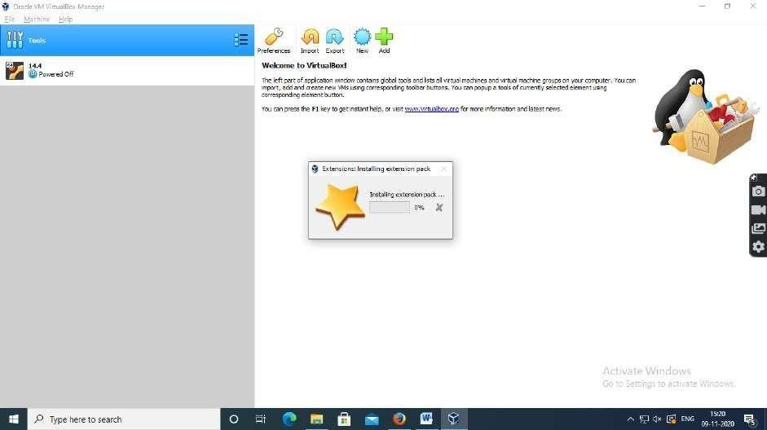

## Oracle VMVirtual Extension pack is imported into the Oracle Virtual Box successfully.

**Step 5:** Click import Appliance and select CentOS-7.8.2003.com OVA (Open Virtual Appliance) file from download directory

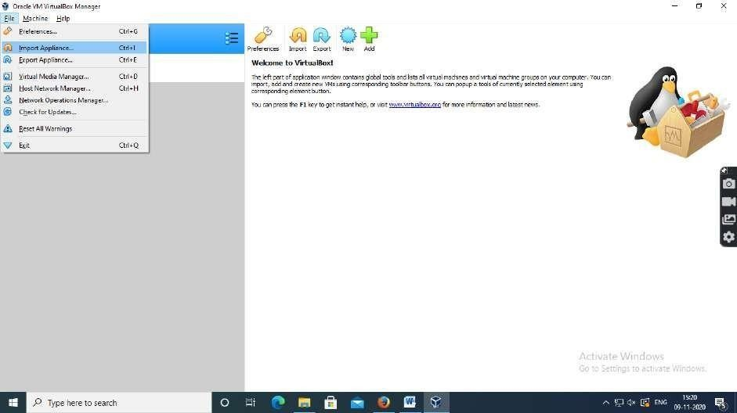

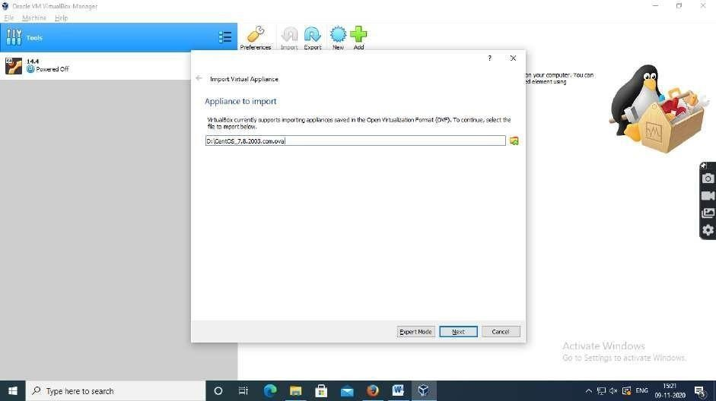

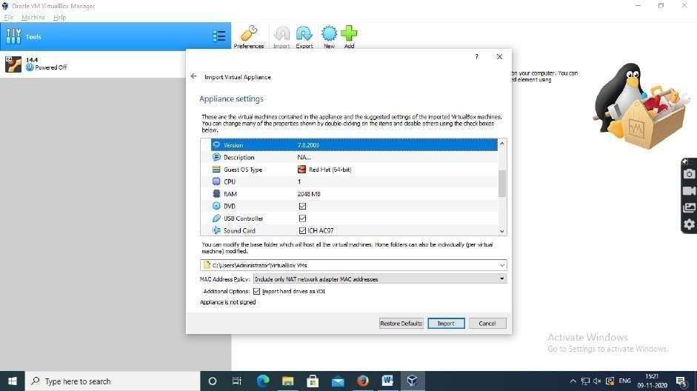

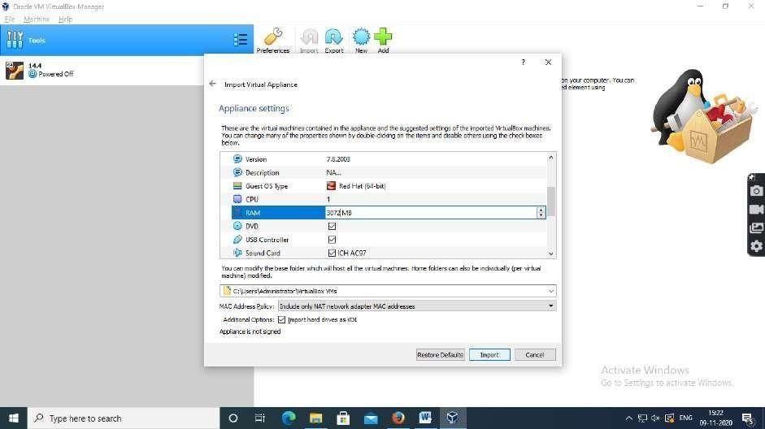

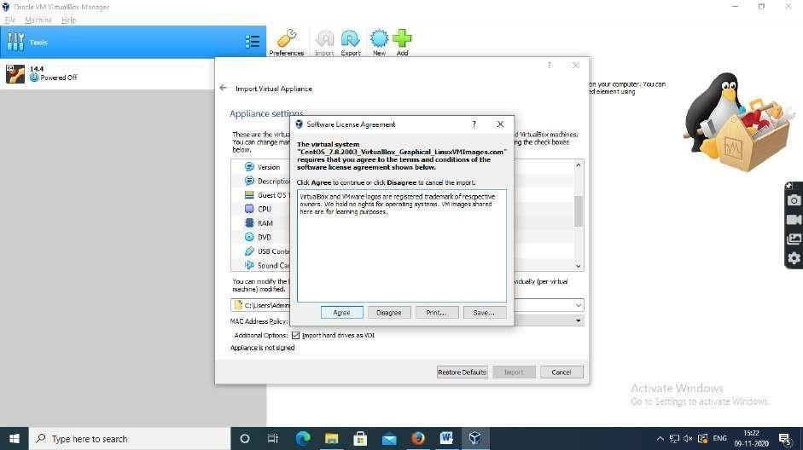

## Installation process started

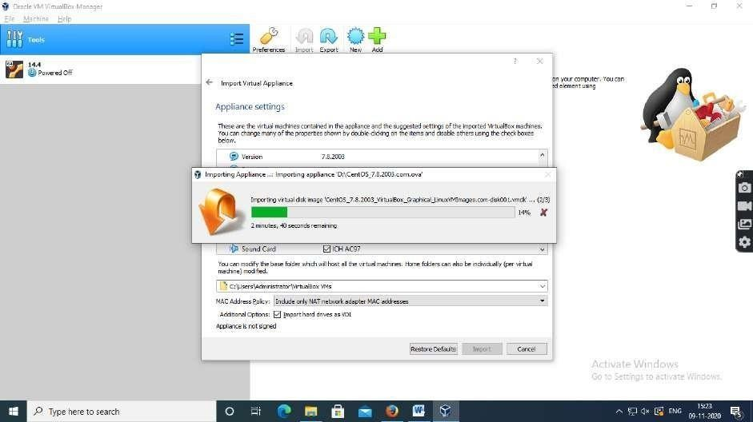

**Step 6:** CentOS-7.8.2003.com is installed successfully and click start button to launch the virtual machine

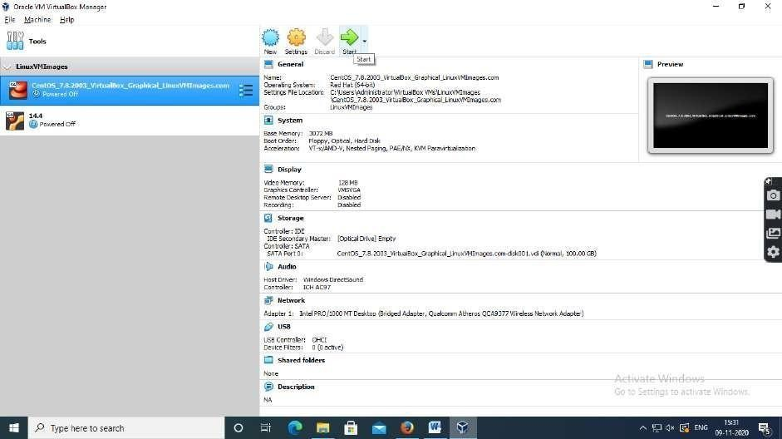

**Step 7:** Login into CentOS 7

* + - Login Details

## User name : centos

* + - * **Password : centos**

## Result:

Oracle VirtualBox is installed with different flavours of CentOS 7 on top of windows 10 successfully.

|  |  |
| --- | --- |
| **EX.NO: 2**  **DATE:** | **Install a C compiler in the virtual machine created using a virtual box and execute Simple Programs.** |

## Steps in Installing C or C++ Compiler in Virtual machine and executing simple programs

**Step 1 :** Install the C or C++ compiler on Ubuntu-14.04 Virtual Machine by

## $ sudo apt install g++

**Step 2:** Create a file for writing C program.

## Source Code:

**$ sudogedit add.c**

## Sum of two numbers

#include<stdio.h> int main()

{

int a,b,c;

printf("Enter two nos:"); scanf("%d%d",&a,&b); c=0;

c=a+b;

printf("Sum of two nos is: %d",c); return 0;

}

**Step 3:** Compile the Program

## $sudo g++ add.c

**Step 4:** Run the Program

## $ ./a.out

**Expected Output:**

Enter two nos : 2 3 Sum of two nos is

## Output:

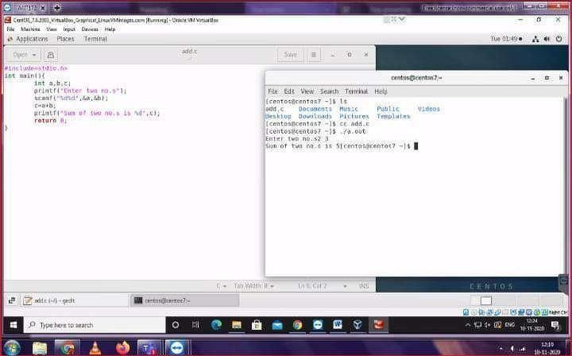

**Result:**

The simple C programs are executed with C compiler in the Virtual Machine successfully and different programs are executed and verified.

|  |  |
| --- | --- |
| **EX.NO: 3 , 4**  **DATE:** | **Install Google App Engine. Create a hello world app and other simple web applications using python/java. Use the GAE launcher to launch the web applications.** |

**Introduction**

## Google Cloud Platform (GCP)

* + **Google Cloud Platform** (**GCP**), offered by [Google,](https://en.wikipedia.org/wiki/Google) is a suite of [cloud](https://en.wikipedia.org/wiki/Cloud_computing) [computing](https://en.wikipedia.org/wiki/Cloud_computing) services that runs on the same infrastructure that Google uses internally for its end-user products, such as [Google Search,](https://en.wikipedia.org/wiki/Google_Search) [Gmail,](https://en.wikipedia.org/wiki/Gmail) [file storage](https://en.wikipedia.org/wiki/Google_Drive), and [YouTube.](https://en.wikipedia.org/wiki/YouTube)
  + Alongside a set of management tools, it provides a series of modular cloud services including computing, [data storage,](https://en.wikipedia.org/wiki/Computer_data_storage) [data analytics](https://en.wikipedia.org/wiki/Data_analysis) and [machine learning.](https://en.wikipedia.org/wiki/Machine_learning)
  + Google Cloud Platform provides [infrastructure as a service,](https://en.wikipedia.org/wiki/Infrastructure_as_a_service) [platform as a](https://en.wikipedia.org/wiki/Platform_as_a_service) [service,](https://en.wikipedia.org/wiki/Platform_as_a_service) and [serverless computing](https://en.wikipedia.org/wiki/Serverless_computing) environments.

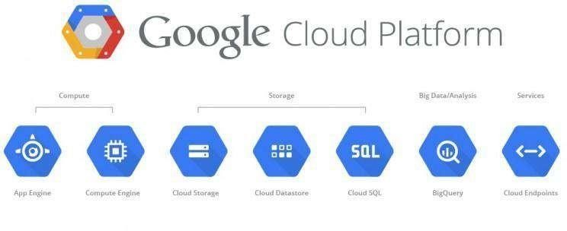

## Platform as a Service (PaaS)

* + Cloud computing service which provides a computing platform and a solution stack as a service.
  + Consumer creates the software using tools and/or libraries from the provider.
  + Provider provides the networks, servers, storage, etc.

## ➢ Google App Engine:

* + Google App Engine was first released as a beta version in April 2008.
  + It is a is a Platform as a Service (PaaS) cloud computing platform for developing and hosting web applications in Google-managed data centers.
  + Google‘s App Engine opens Google‘s production to any person in the world at no charge.
  + Google App Engine is software that facilitates the user to run his web applications on Google infrastructure.
  + It is more reliable because failure of any server will not affect either the performance of the end user or the service of the Google.
  + It virtualizes applications across multiple servers and data centers.
    - Other cloud-based platforms include offerings such as Amazon Web Services and Microsoft's Azure Services Platform.

## Introduction of Google App Engine

* Google App Engine lets you run your web applications on Google's infrastructure. App Engine applications are easy to build, easy to maintain,and easy to scale as your traffic and data storage needs grow. With App Engine, there are no servers to maintain: You just upload your application, and it's ready to serve your users.
* You can serve your app from your own domain name (such as https:/[/www.example.com/)](http://www.example.com/)) using Google Apps. Or, you can serve your app using a free name on the appspot.com domain. You can share your application with the world, or limit access to members of your organization.
* Google App Engine supports apps written in several programming languages. With App Engine's Java runtime environment, you can build your app using standard Java technologies, including the JVM, Java servlets, and the Java programming language—or any other language using a JVM-based interpreter or compiler, such as JavaScript or Ruby. App Engine also features a dedicated Python

runtime environment, which includes a fast Python interpreter and the Python standard library. The Java and Python runtime environments are built to ensure that your application runs quickly, securely, and without interference from other apps on the system.

* With App Engine, you only pay for what you use. There are no set-up costs and no recurring fees. The resources your application uses, such as storage and bandwidth, are measured by the gigabyte, and billed at competitive rates. You control the maximum amounts of resources your app can consume, so it always stays within your budget. App Engine costs nothing to get started. All applications can use up to 500 MB of storage and enough CPU and bandwidth to support an efficient app serving around 5 million page views a month,absolutely free. When you enable billing for your application, your free limits are raised, and you only pay for resources you use above the free levels.

## Architecture of Google App Engine

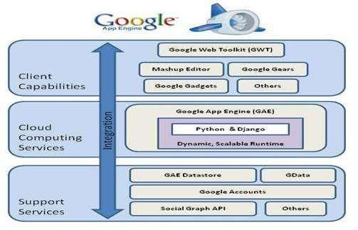

* **Features of Google App Engine**

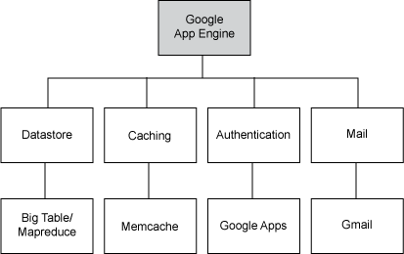

## GAE Application Environment:

* Google App Engine makes it easy to build an application that runs reliably, even under heavy load and with large amounts of data. App Engine includes the following features:
* Persistent storage with queries, sorting and transactions
* Automatic scaling and load balancing
* APIs for authenticating users and sending email using Google Accounts
* Task queues for performing work outside of the scope of a web request
* Scheduled tasks for triggering events at specified times and regular intervals
* Dynamic web serving, with full support for common web technologies

## Java Runtime Environment

* You can develop your application for the Java runtime environment using common Java web development tools and API standards. Your app interacts with the environment using the Java Servlets standard, and can use common web application technologies such as Java Server Pages
* The Java runtime environment uses Java 6. The App Engine Java SDK supports developing apps using either Java 5 or 6. The environment includes the Java SE Runtime Environment (JRE) 6

platform and libraries. The restrictions of the sandbox environment are implemented in the JVM. An app can use any JVM byte code or library feature, as long as it does not exceed the sandbox restrictions. For instance, byte code that attempts to open a socket or write to a file will throw a runtime exception.

* Your app accesses most App Engine services using Java standard APIs. For the App Engine data store, the Java SDK includes implementations of the Java Data Objects (JDO) and Java Persistence API (JPA) interfaces. Your app can use the JavaMail API to send email messages with the App Engine Mail service. The java.net HTTP APIs accesses the App Engine URL fetch service.
* App Engine also includes low-level APIs for its services to implement additional adapters, or to use directly from the application. See the documentation for the data store, memcache, URL fetch, mail, images and Google Accounts APIs. Typically, Java developers use the Java programming language and APIs to implement web applications for the JVM. With the useof JVM-compatible compilers or interpreters, you can also use other languages to develop web applications, such as JavaScript, Ruby.

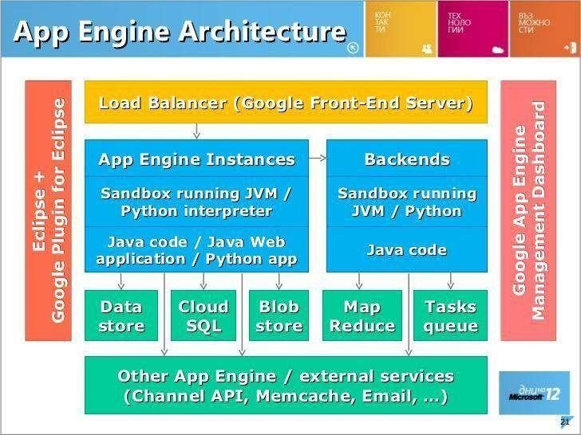

## Workflow of Google App Engine

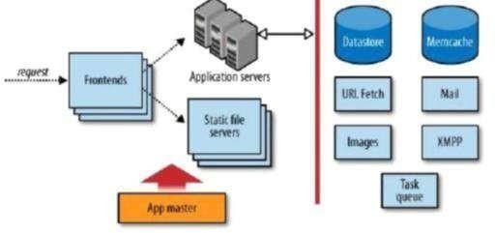

**Step1 : Login to** [**www.cloud.google.com**](http://www.cloud.google.com/)

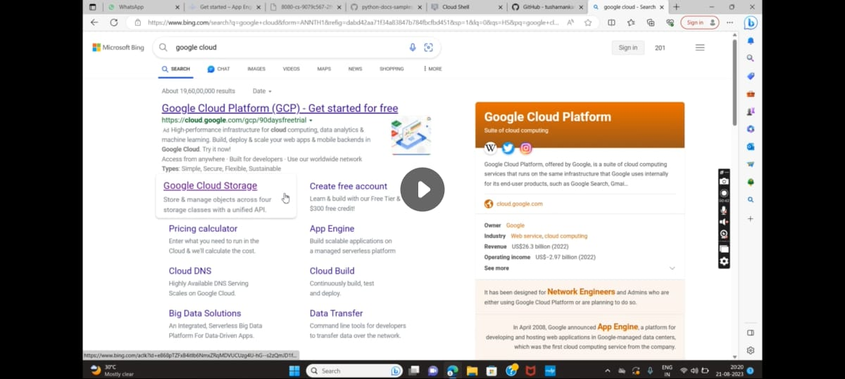

## Step2 : Goto Console

## Step 3 : Google Cloud Platform is shown . Click Dashboard in the Google Cloud Plaform

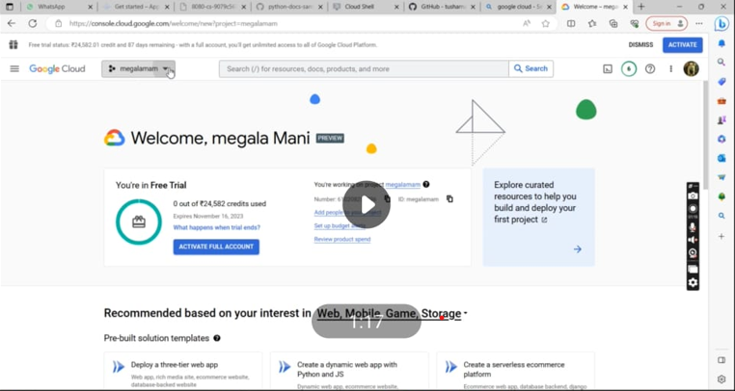

## Step 4 : Since the page called select a project will be visible in that click new project.

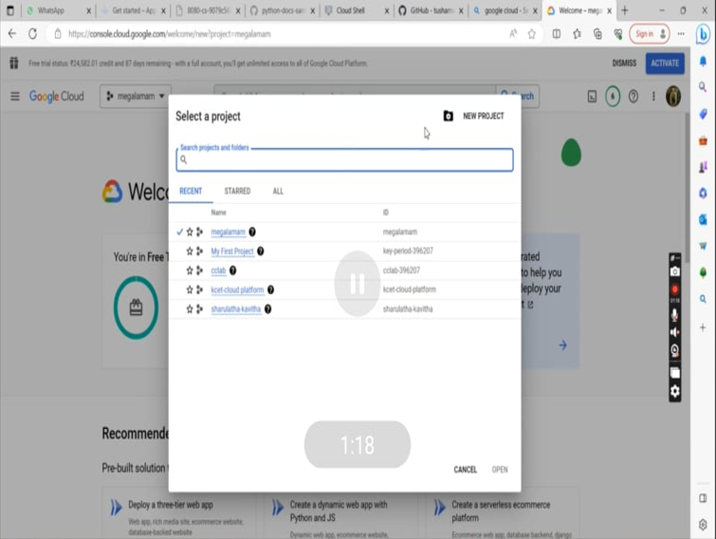

## Step 5 : Click New Project and give unique Project Name.

**Example :** sharu

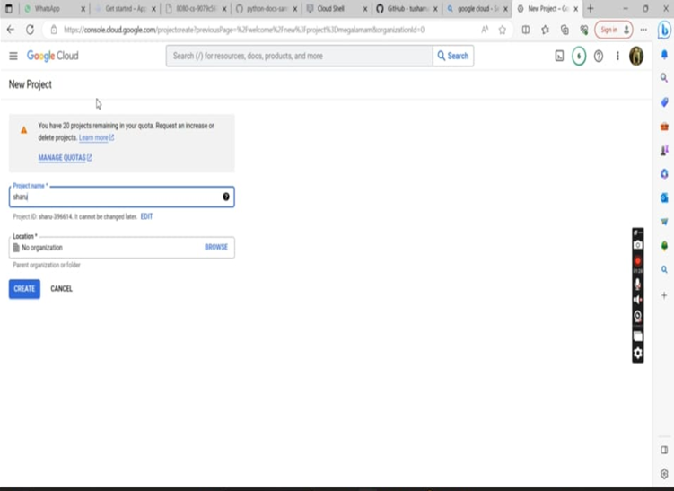

## Step 6 : Now, a notification will be given as “ the project is created “. Then click on select project.

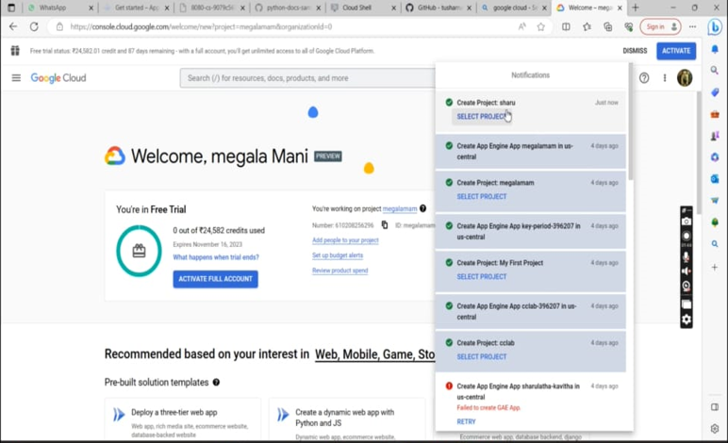

## Step 7 : In dashboard , click on products and solutions. Later click on all products.

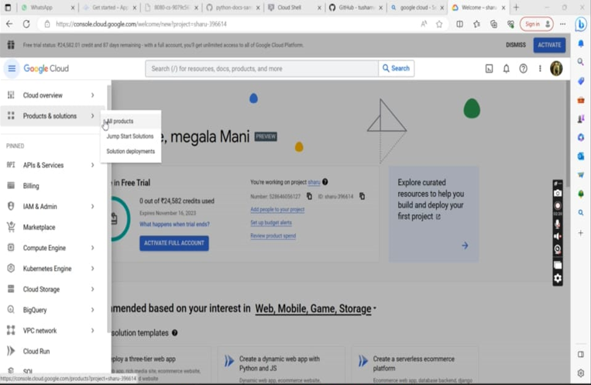

**Step 8 : In next page click the serverless.**

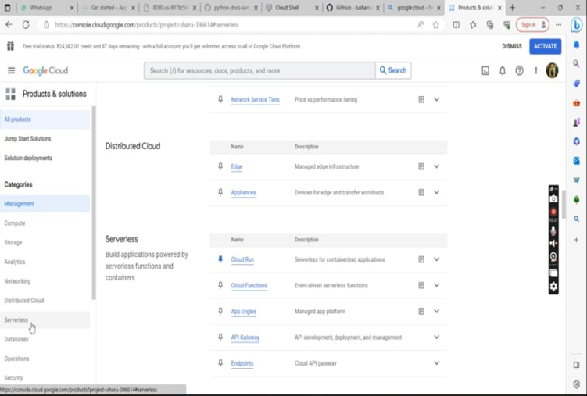

## Step 9 : In that , click App Engine to initiate it.

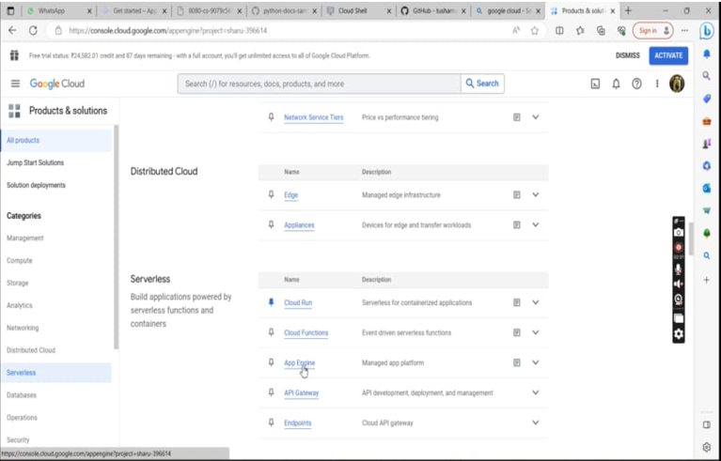

**Step 10 : A new page will be opened ,then click the create application.**

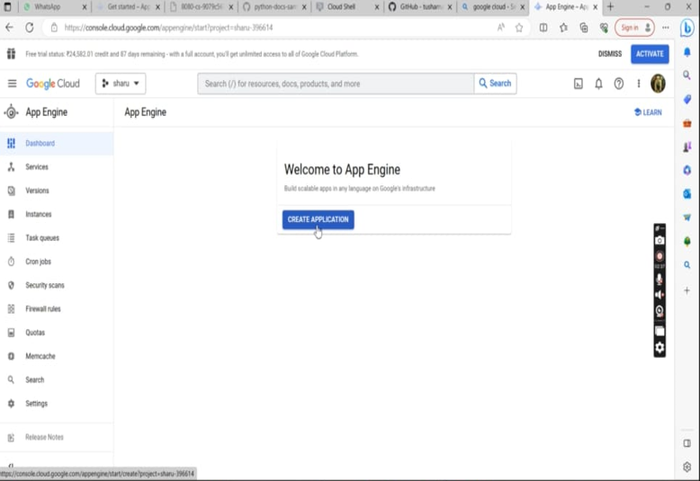

## Step 11 : It navigates to a new page , there click next simply.

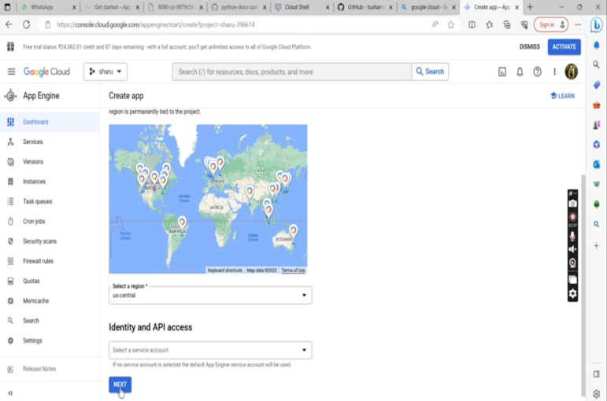

**Step 12 : Then the python app engine page is show . There give the details :-**

**In place of , language – python and environment – flexible.**

**Later click on the github link provided in that page.**

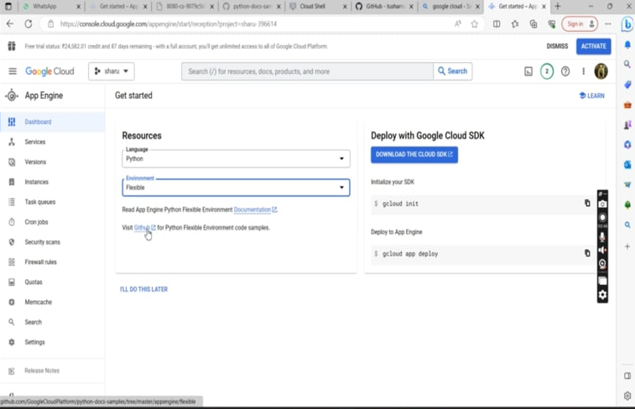

## Step 13 : In that page, go to url given . Copy the url link till samples.

## Then move back to the previous page.

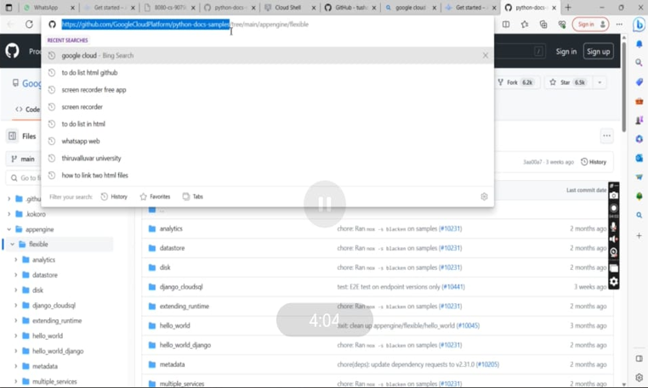

## Step 14 : While cliking the download cloud sdk . It will navigate to a page -Make a billing account set a common email-id and a password. There click the activate cloud shell.

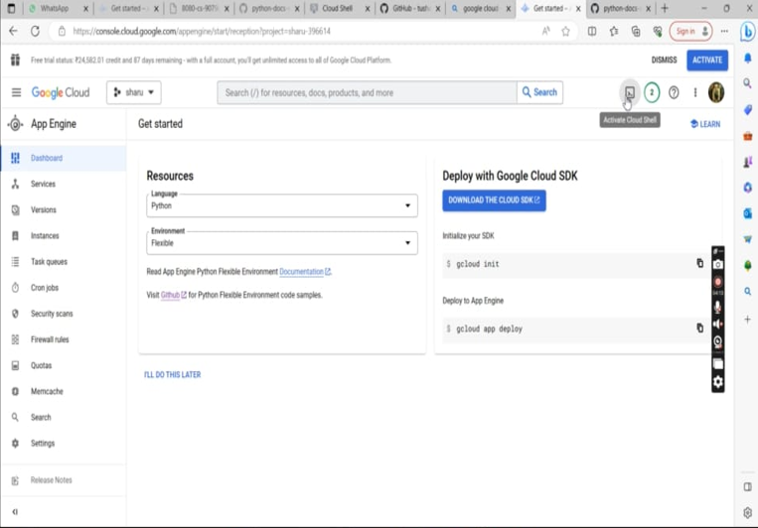

**Step 15 : The cloud shell is initiated. Type - git clone and copy the url that was been copied in the github page. Hit enter. It’s time to change the directory using the command :- cd python-docs-samples/ . Then type the cmd:- cd appengine/ .**

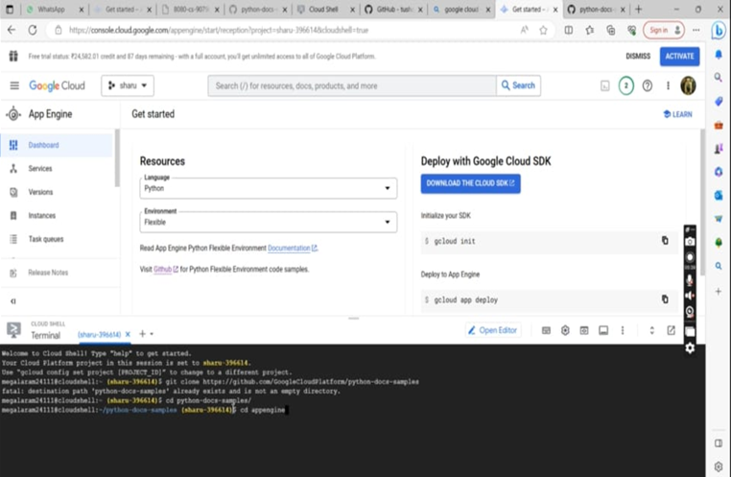

## Step 16 : Next click the cloud editor.

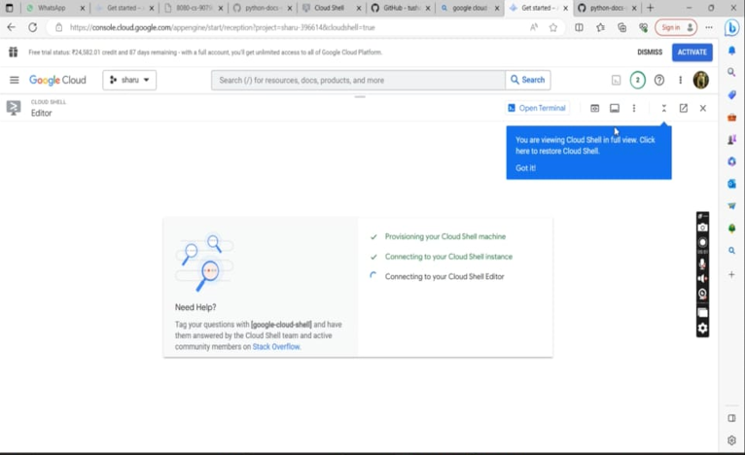

**Step 17 : So that , the cloud editor page gets initiated.**

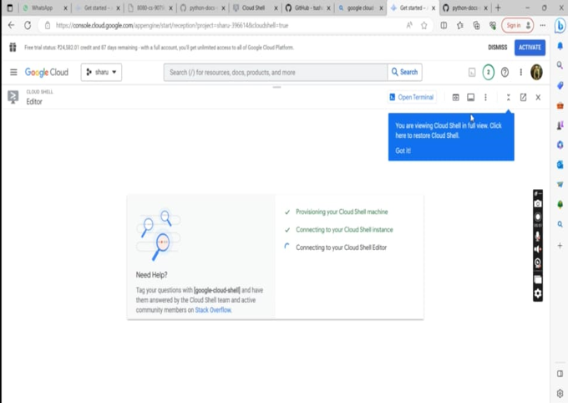

**Step 18 : Create a folder .**

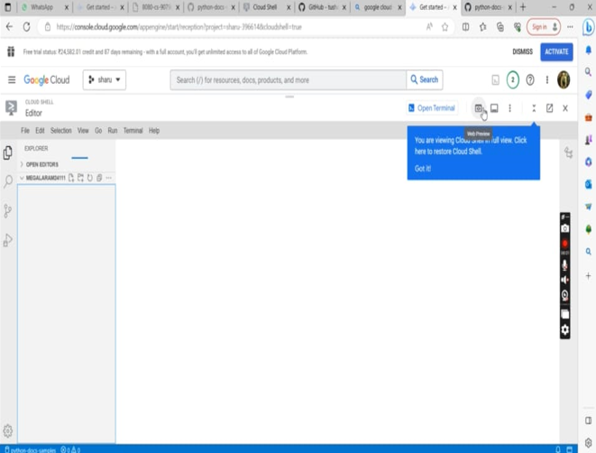

**Step 19 : In that folder create a file called main.py . A code in python is witten in that page as given in that figure given.**

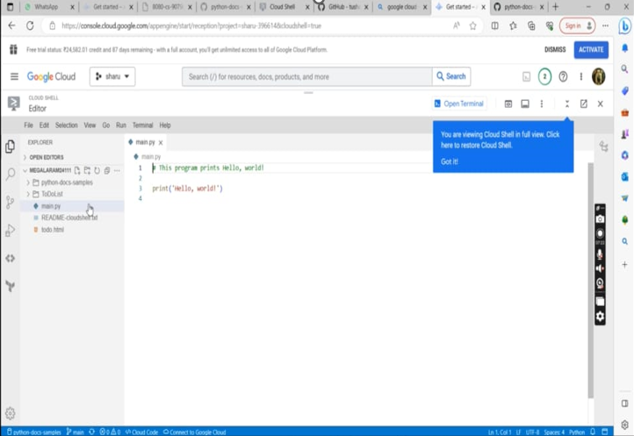

**Step 20 : enter the cmd :-**

1. **Cd flexible/**
2. **Cd hello_world , ls**
3. **Python3 main.py**

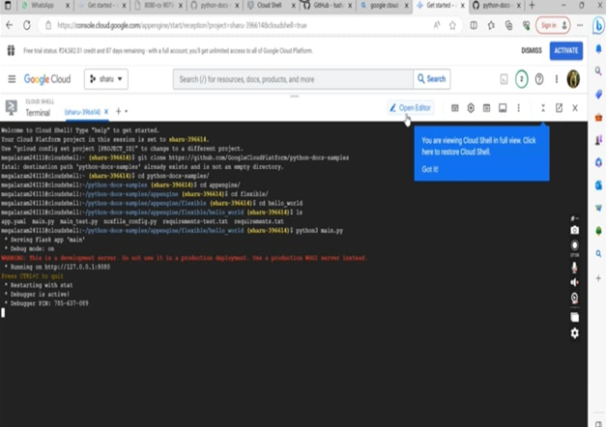

**Step 21: Then click on that url given in the cloud shell page. It will generate the output in a new page as “Hello World!”**

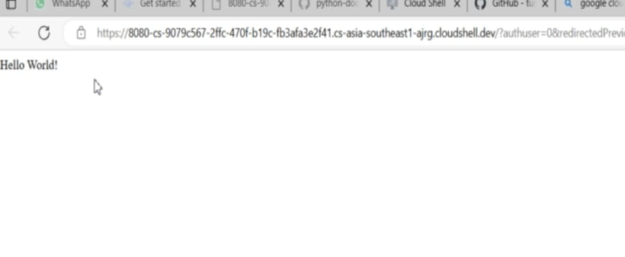

**Todo list code in HTML:**

<!DOCTYPE html>

<html>

<head>

<meta name="viewport" content="width=device-width, initial-scale=1">

<style>

body {

margin: 0;

min-width: 250px;

}

/* Include the padding and border in an element's total width and height */

* {

box-sizing: border-box;

}

/* Remove margins and padding from the list */

ul {

margin: 0;

padding: 0;

}

/* Style the list items */

ul li {

cursor: pointer;

position: relative;

padding: 12px 8px 12px 40px;

list-style-type: none;

background: #eee;

font-size: 18px;

transition: 0.2s;

/* make the list items unselectable */

-webkit-user-select: none;

-moz-user-select: none;

-ms-user-select: none;

user-select: none;

}

/* Set all odd list items to a different color (zebra-stripes) */

ul li:nth-child(odd) {

background: #f9f9f9;

}

/* Darker background-color on hover */

ul li:hover {

background: #ddd;

}

/* When clicked on, add a background color and strike out text */

ul li.checked {

background: #888;

color: #fff;

text-decoration: line-through;

}

/* Add a "checked" mark when clicked on */

ul li.checked::before {

content: '';

position: absolute;

border-color: #fff;

border-style: solid;

border-width: 0 2px 2px 0;

top: 10px;

left: 16px;

transform: rotate(45deg);

height: 15px;

width: 7px;

}

/* Style the close button */

.close {

position: absolute;

right: 0;

top: 0;

padding: 12px 16px 12px 16px;

}

.close:hover {

background-color: #f44336;

color: white;

}

/* Style the header */

.header {

background-color: #f44336;

padding: 30px 40px;

color: white;

text-align: center;

}

/* Clear floats after the header */

.header:after {

content: "";

display: table;

clear: both;

}

/* Style the input */

input {

margin: 0;

border: none;

border-radius: 0;

width: 75%;

padding: 10px;

float: left;

font-size: 16px;

}

.addBtn {

padding: 10px;

width: 25%;

background: #d9d9d9;

color: #555;

float: left;

text-align: center;

font-size: 16px;

cursor: pointer;

transition: 0.3s;

border-radius: 0;

}

.addBtn:hover {

background-color: #bbb;

}

</style>

</head>

<body>

<div id="myDIV" class="header">

<h2 style="margin:5px">My To Do List</h2>

<input type="text" id="myInput" placeholder="Title...">

<span onclick="newElement()" class="addBtn">Add</span>

</div>

<ul id="myUL">

<li>Hit the gym</li>

<li class="checked">Pay bills</li>

<li>Meet George</li>

<li>Buy eggs</li>

<li>Read a book</li>

<li>Organize office</li>

</ul>

<script>

// Create a "close" button and append it to each list item

var myNodelist = document.getElementsByTagName("LI");

var i;

for (i = 0; i < myNodelist.length; i++) {

var span = document.createElement("SPAN");

var txt = document.createTextNode("\u00D7");

span.className = "close";

span.appendChild(txt);

myNodelist[i].appendChild(span);

}

var close = document.getElementsByClassName("close");

var i;

for (i = 0; i < close.length; i++) {

close[i].onclick = function() {

var div = this.parentElement;

div.style.display = "none";

}

}

// Add a "checked" symbol when clicking on a list item

var list = document.querySelector('ul');

list.addEventListener('click', function(ev) {

if (ev.target.tagName === 'LI') {

ev.target.classList.toggle('checked');

}

}, false);

// Create a new list item when clicking on the "Add" button

function newElement() {

var li = document.createElement("li");

var inputValue = document.getElementById("myInput").value;

var t = document.createTextNode(inputValue);

li.appendChild(t);

if (inputValue === '') {

alert("You must write something!");

} else {

document.getElementById("myUL").appendChild(li);

}

document.getElementById("myInput").value = "";

var span = document.createElement("SPAN");

var txt = document.createTextNode("\u00D7");

span.className = "close";

span.appendChild(txt);

li.appendChild(span);

for (i = 0; i < close.length; i++) {

close[i].onclick = function() {

var div = this.parentElement;

div.style.display = "none";

}}

}

</script>

</body>

</html>

**Step 22: The page where you typed the file called main.py , create a new file called**

**todo.html .This is to make a web application. Type the above given code.**

**After typing the code , click on cloud code.**

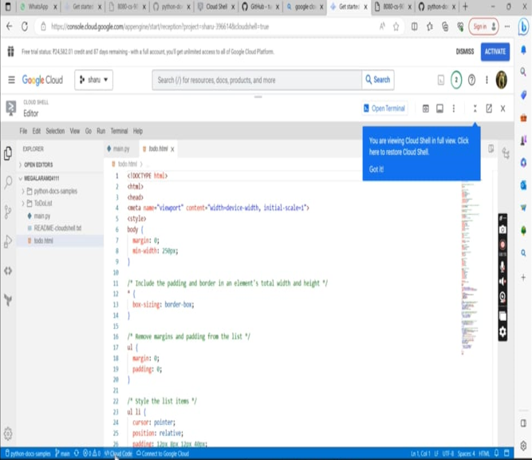

## Step 23: It will ask for the authentication. In that click on authorize.

## 

## Step 24: Then by clicking the terminal the output will be shown in that page itself.

## 

## Result:

## Thus the Google App Engine is installed successfully and a web application to display hello world using python is developed and deployed in the GAE and used GAE Launcher to launch the web applications.

|  |  |
| --- | --- |
| **EX NO: 5**    **DATE:** | **Simulate a cloud scenario using CloudSim and run a scheduling algorithm that is not present in CloudSim.** |

## Introduction:

* **CloudSim**
  + A Framework for modeling and simulation of Cloud Computing Infrastructures and services
  + Originally built at the Cloud Computing Distributed Systems (CLOUDS) Laboratory, The University of Melbourne, Australia
  + It is completely written in JAVA

## Main Features of CloudSiM

* Modeling and simulation
* Data centre network topologies and message-passing applications
* Dynamic insertion of simulation elements
* Stop and resume of simulation
* Policies for allocation of hosts and virtual machines

## Cloudsim – Essentials

* + JDK 1.6 or above <http://tinyurl.com/JNU-JAVA>
  + Eclipse 4.2 or above <http://tinyurl.com/JNU-Eclipse>
  + Program link: [cloudsim-task-scheduling/src/SJF/SJFDatacenterBroker.java at master · michaelfahmy/cloudsim-task-scheduling · GitHub](https://github.com/michaelfahmy/cloudsim-task-scheduling/blob/master/src/SJF/SJFDatacenterBroker.java)
  + Up & Running with cloudsim guide: https://goo.gl/TPL7Zh

## Cloudsim-Directory structure

* + cloudsim/ -- top level CloudSim directory
  + docs/ -- CloudSim API Documentation
  + examples/ -- CloudSim examples
  + jars/ -- CloudSim jar archives
  + sources/ -- CloudSim source code

Cloudsim - Layered Architecture

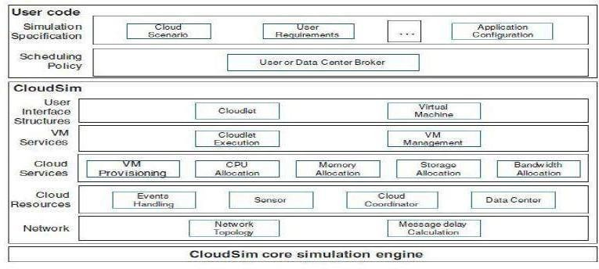

Step 1: Go to Google enter the link <https://www.eclipse.org/downloads/> . Installing eclipse.

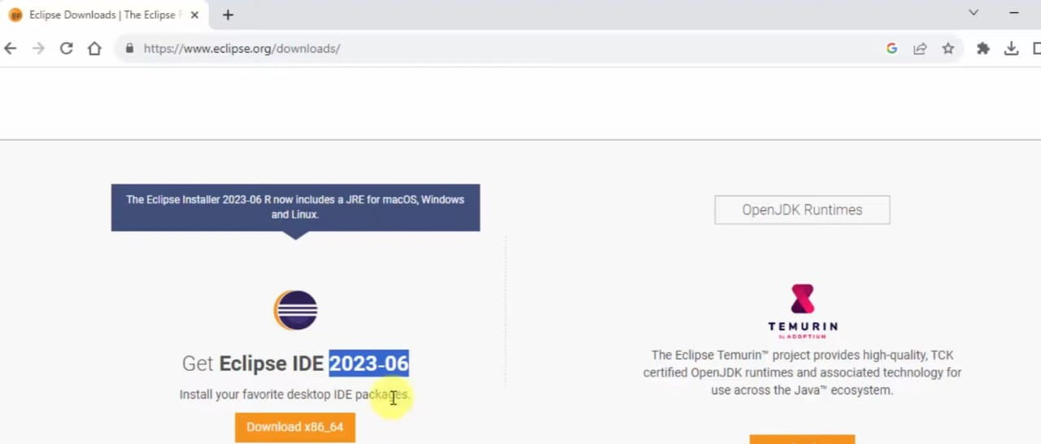

Step 2: Click on download button .

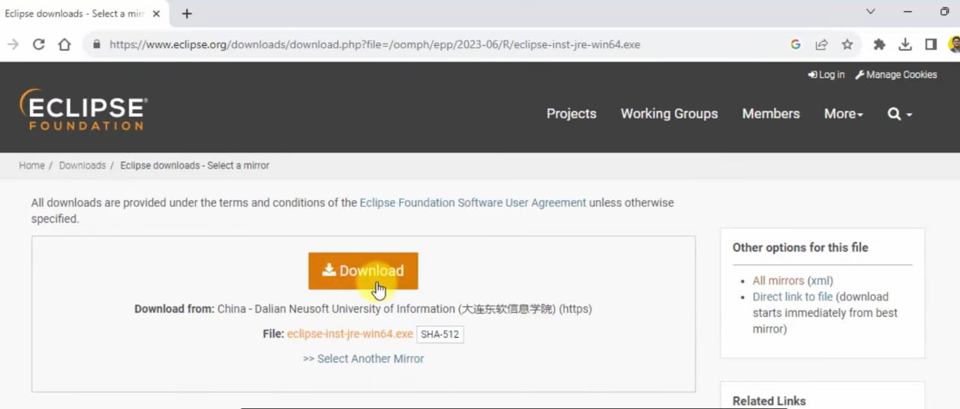

Step 3: After installing the exe file , click that and give “ Run as Administrator” . Once installation is done, click that installed eclipse. Here click on the eclicpse IDE for java developers.

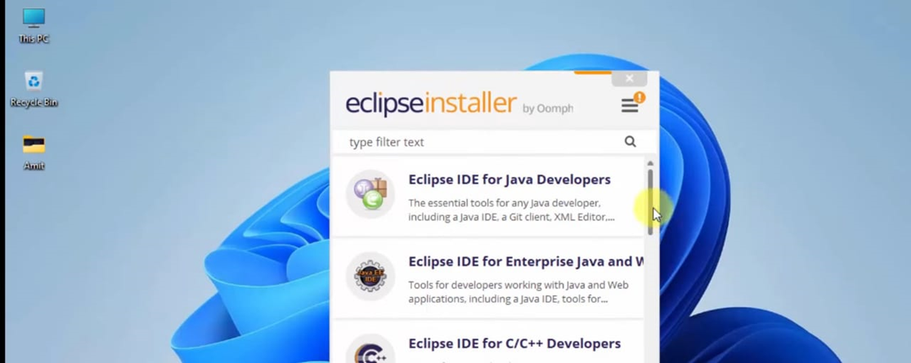

Step 4: Then it gives this page , here if we already have java jdk link the path to eclipse else download java jdk. Once installed jdk link it to eclipse. After all this configuration click on the install button.

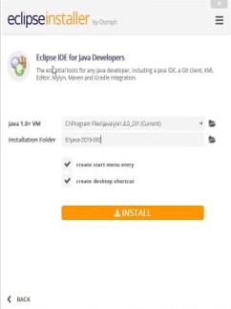

Step 5: After the installation gets started.

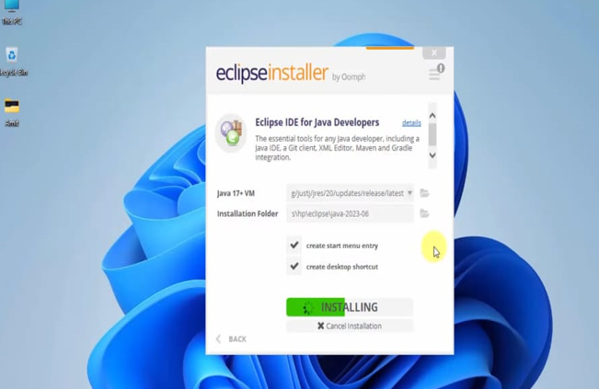

Step 6: Once the installation is completed it will ask to launch. Click on launch.



Step 7: It will ask for a directory . simply click launch.

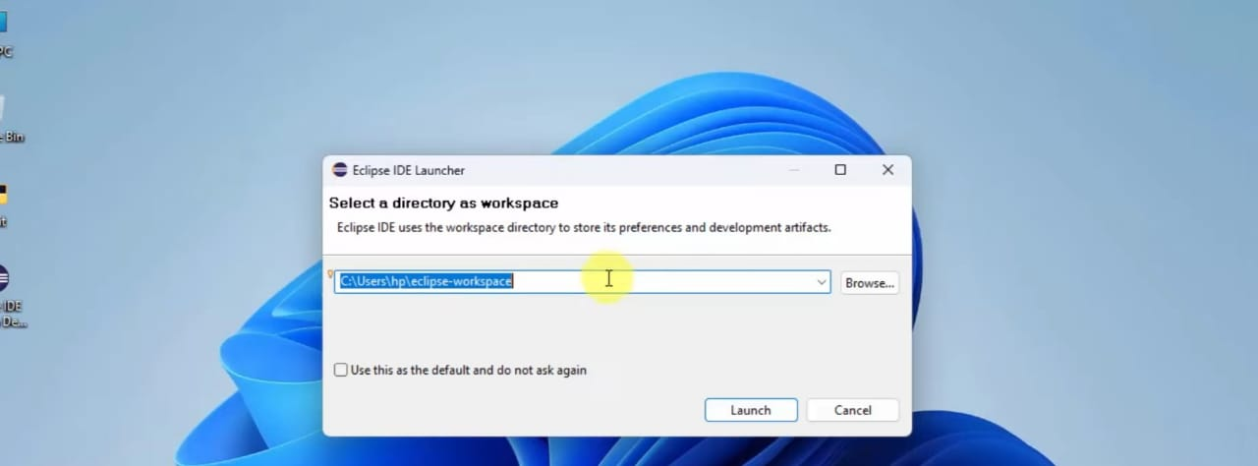

Step 8: Its time to install cloudsim. Since download it for windows.

It will be provided as a jar file using winrar or any other software extract that file.

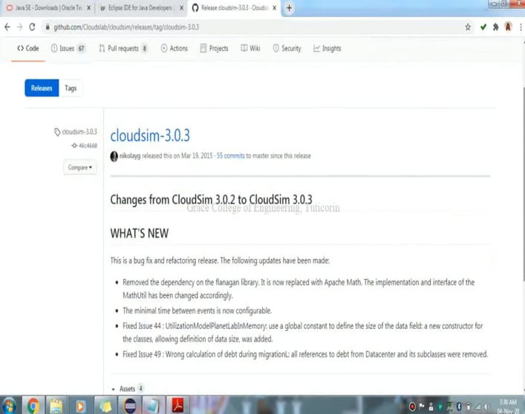

Step 9: Thus all the requirements are installed.

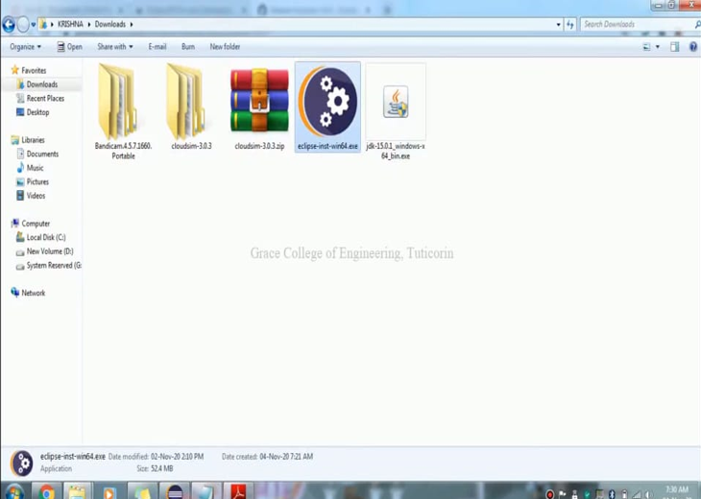

Step 10: click on the eclipse.

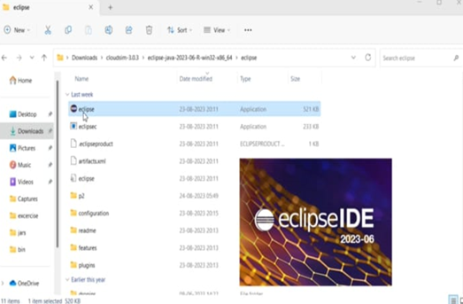

Step 11: click on new then go to java project and click it.

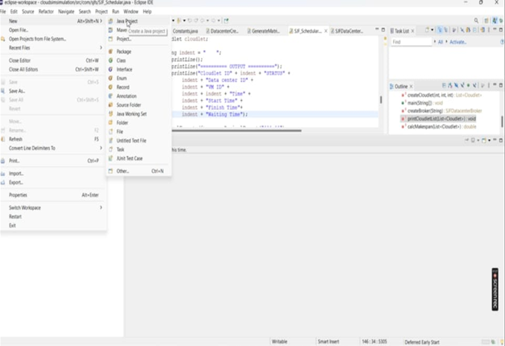

Step 12: give a project name .

(Example: cclab ) then click on next.

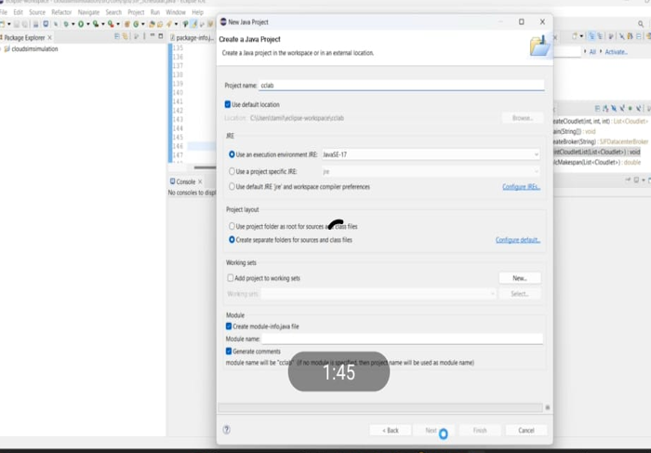

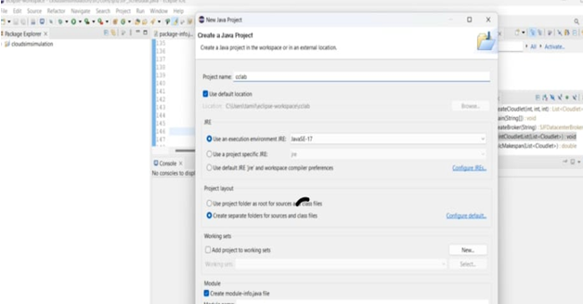

Step 13: Since the project was created . click on that .

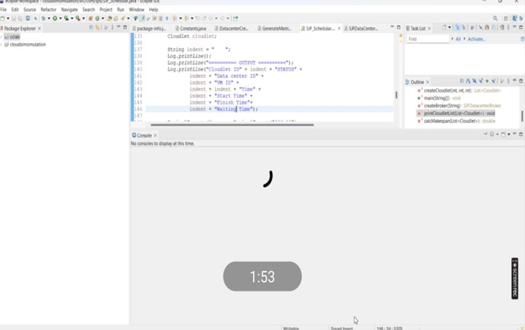

Step 14: After this the java settings will be opened . Just click on finish to confirm our setups .

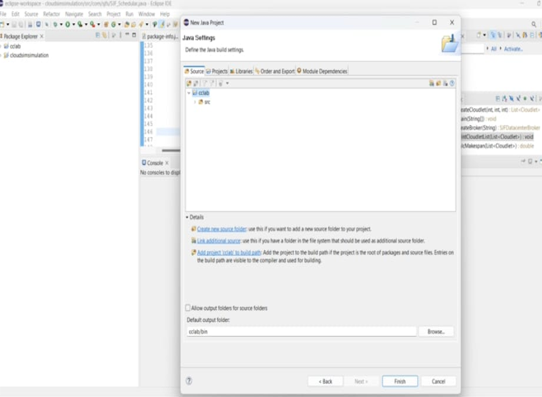

Step 15: The src will be created as a sub directory of the project we have created. Do right click that , in new choose a package

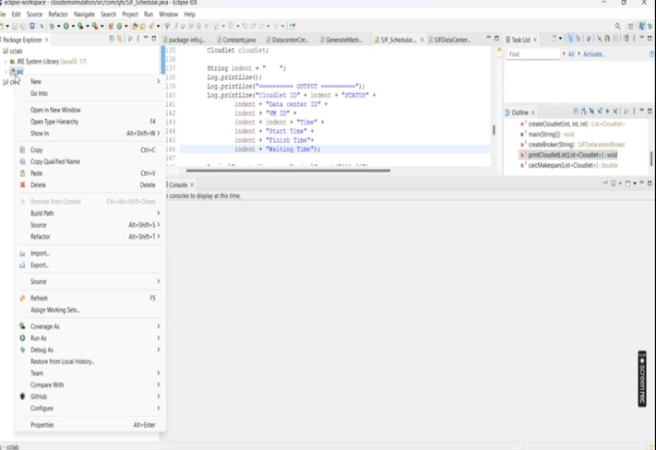

Step 16: give the package name as com.sjfs

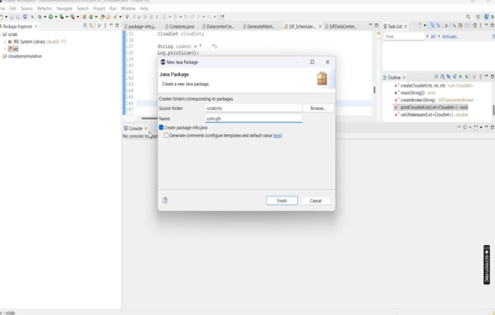

Step 17: Later see whether the check box is ticked or not . If ticked leave as it as else mark the check box . Then click finish.

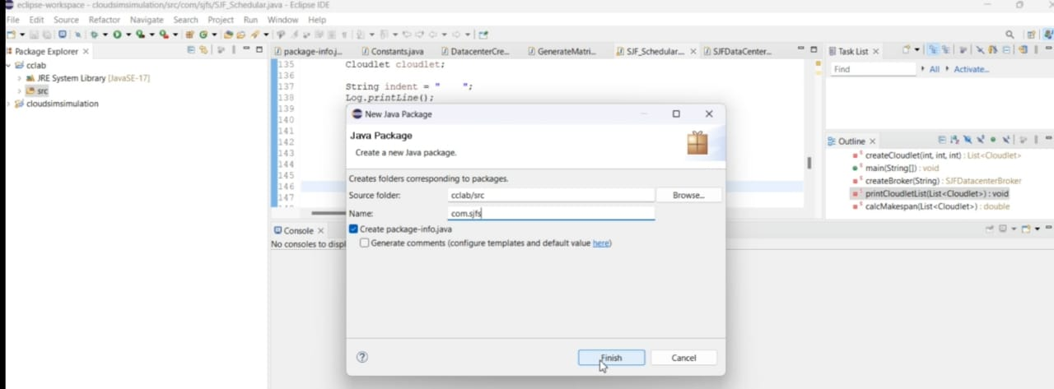

Step 18: Then refresh the page . here the package com.sjfs is seen.

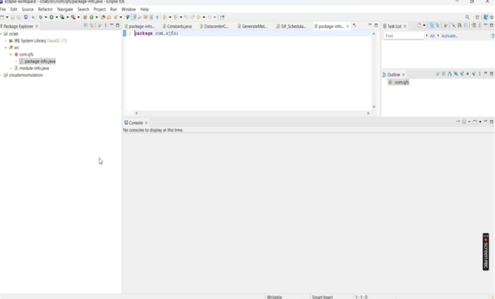

Step 19: Do right click the com.sjfs there click “show in” within that click system explorer.

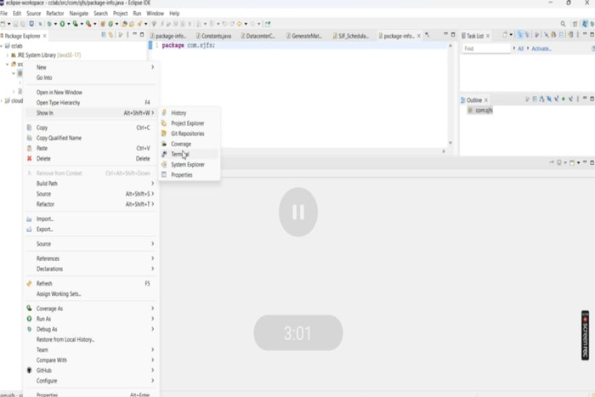

Step 20: here the file path where the file is created will be displayed .

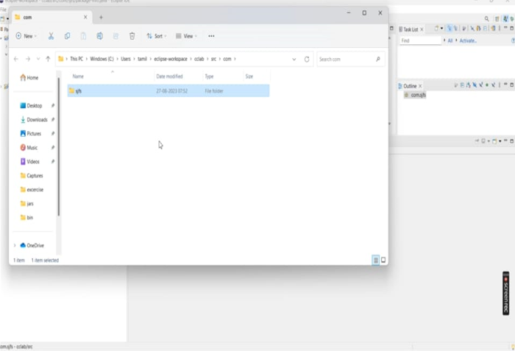

Step 21: Then click the src , within that package.sjfs will be shown.

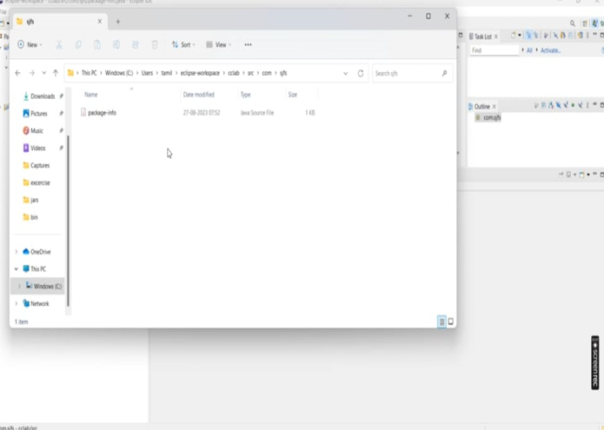

Step 22: There add 4 more files that links the cloud sim concept and the java program for sjfs that is shortest job first. Since copy the files from github.

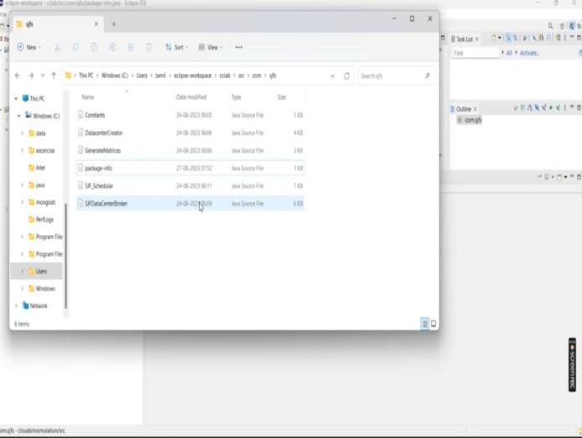

Step 23: do refresh the page and will be able to see the files we are added.

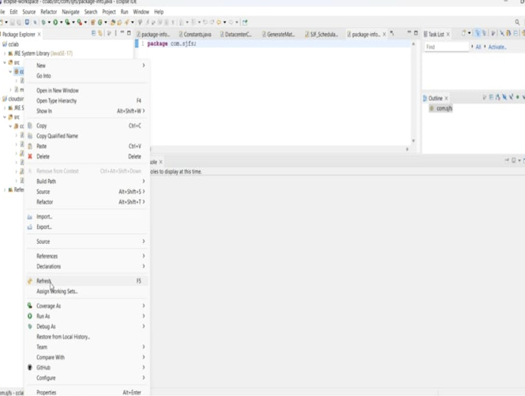

Step 24: The files that are added will be shown . Do some changes in the files only in the first line as the package name to be com.sjfs

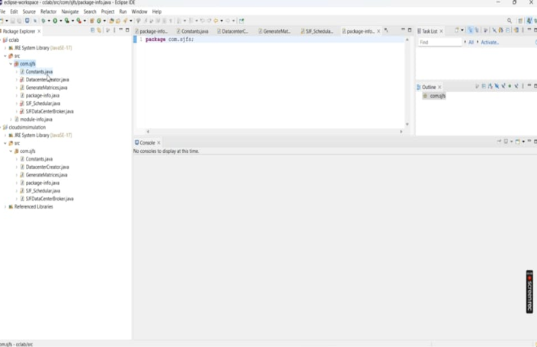

Step 25: Again click the src within that click build path then click the configured path.

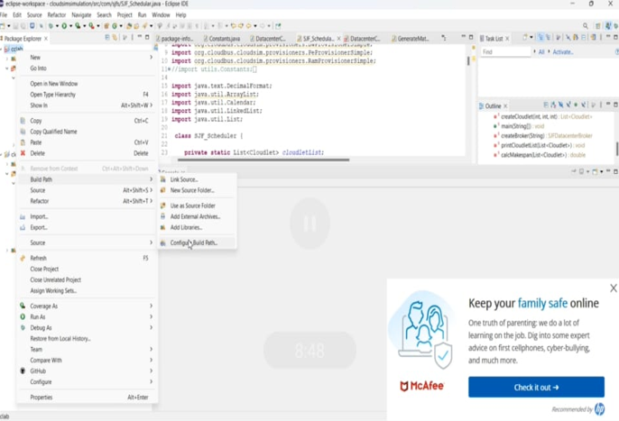

Step 26: here click the java build path within that ,click the add extract files.

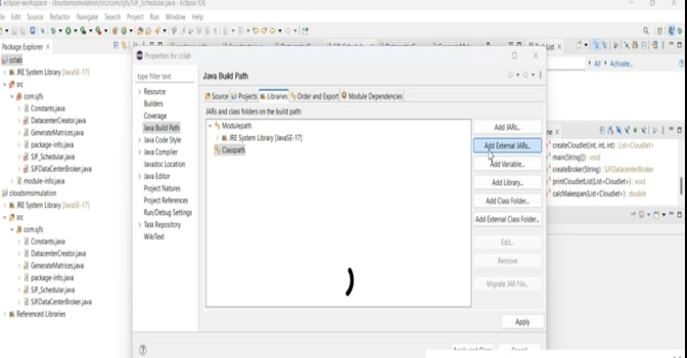

Step 27:within that choose the cloudsim file.

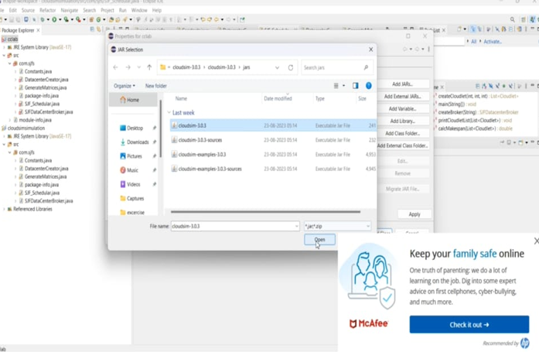

Step 28: then click the apply and close close button.

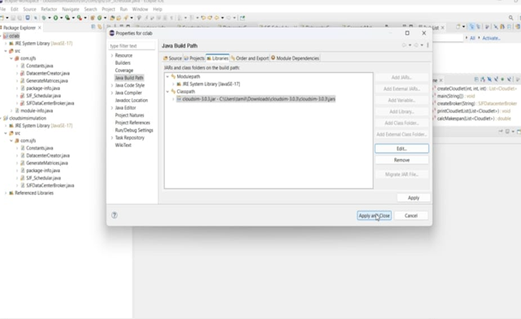

Step 29: Now keep the SJF_Schedular.java file. Do right click then click “run as and run configure”

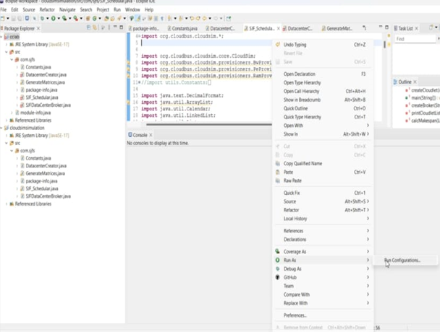

Step 30:click the run button.

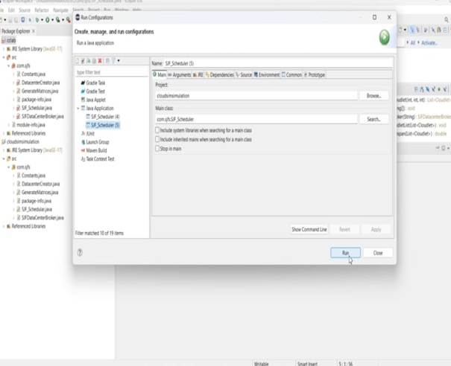

Step 31: The output will be displayed as follows.

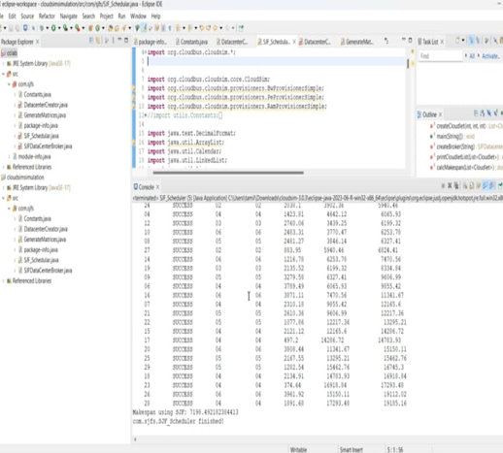

Result:

Thus the cloudsim is simulated using Eclipse Environment successfully

|  |  |
| --- | --- |
| **EX NO: 6**    **DATE:** | **Find a procedure to transfer the files from one virtual machine to another virtual machine** |

# Aim:

To procedure File Transfer in Client & Server using virtual machine

# Steps:

Steps to perform File Transfer in Client & Server using virtual machine.

Step 1: Open a virtual machine to do file transfer.

Step 2: Write the java program for FTP Client and FTP Server. Step 3: Run the program.

# Source Code:

**FTPClient.java** import java.io.*; import java.net.*; import java.util.*;

public class FTPClient{

public static void main(String args[])throws IOException { try {

int number;

Socket s=new Socket("127.0.0.1",10087); Scanner sc=new Scanner(System.in); System.out.println("Enter the file name:"); String fn=sc.next();

DataOutputStream dos=new DataOutputStream(s.getOutputStream()); dos.writeUTF(fn);

DataInputStream dis=new DataInputStream(s.getInputStream()); String input=(String)dis.readUTF();

FileInputStream fis=new FileInputStream(input); System.out.println("The file “ +fn+ “consists of numbers”); int i=0;

while((i=fis.read())!=-1){ System.out.println((char)i);

}

s.close();

}

catch(Exception e){

System.out.println("Port not available "+e);

}

}

}

**FTPServer.java** import java.io.*; import java.net.*; import java.util.*;

public class FTPServer{

public static void main(String args[])throws IOException{ try{

int num;

Scanner sc=new Scanner(System.in); ServerSocket ss=new ServerSocket(10087); Socket s=ss.accept(); System.out.println("Waiting ");

DataInputStream dis=new DataInputStream(s.getInputStream()); String input=(String)dis.readUTF();

DataOutputStream dos=new DataOutputStream(s.getOutputStream()); FileInputStream fis = new FileInputStream("out.txt"); FileOutputStream fos = new FileOutputStream(input); while((num=fis.read())!= -1) {

if(num%2==0) {

fos.write(num);

}

}

dos.writeUTF(input); System.out.println("File is sent to client"); ss.close();

s.close();

}

catch(Exception e) {

System.out.println("Port not available"+e);

}

}

}

# Out.txt

1

2

3

4

5

6

7

8

9

# Output:

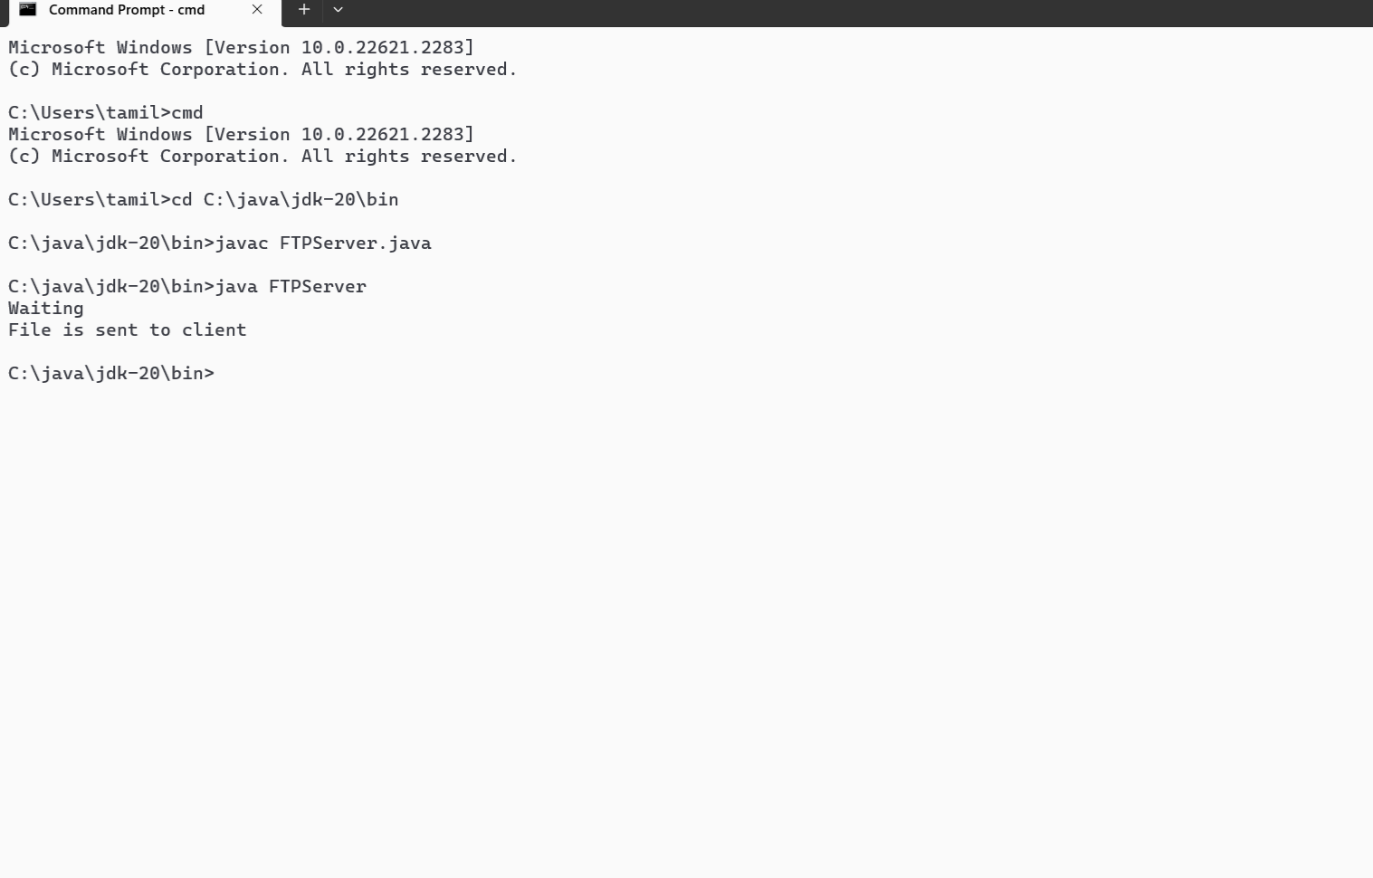

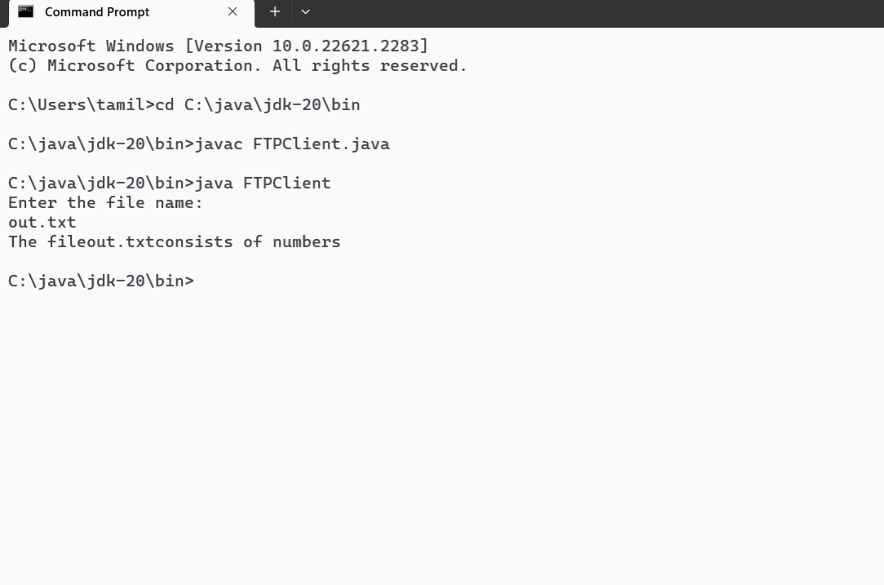

**Result:**

Thus the program was successfully verified.

|  |  |
| --- | --- |
| **EX NO: 7**    **DATE:** | **Install Hadoop single node cluster and run simple applications like wordcount.** |

AIM:

Install Hadoop single node cluster and run simple applications like wordcount.

Java Installation and Configuration

Java Download

As stated in [Hadoop Java Versions:](https://cwiki.apache.org/confluence/display/HADOOP/Hadoop%2BJava%2BVersions)

Apache Hadoop 3.3 and upper supports Java 8 and Java 11 (runtime only), but Hadoop compilation with Java 8 is mandatory.

Apache Hadoop from 3.0.x to 3.2.x now supports only Java 8. Apache Hadoop from 2.7.x to 2.10.x support both Java 7 and 8.

In this guide, I will explain how to install Hadoop 3.2.2, so you need Java 8.

[First of all, you need an Oracle account. If you don’t have one create it here. The](https://profile.oracle.com/myprofile/account/create-account.jspx) [procedure is very straightforward, you just need to complete](https://profile.oracle.com/myprofile/account/create-account.jspx) a form and verify your email.

[After your Oracle account is created, you need to go to Windows Java 8 SE](https://www.oracle.com/java/technologies/downloads/#java8-windows) [Development Kit official download site and download the x64 Installer:](https://www.oracle.com/java/technologies/downloads/#java8-windows)

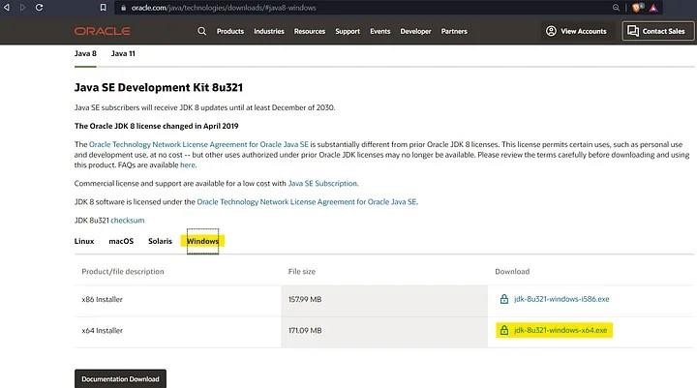

[Then, you will be asked to accept (clicking on the checkbox) the Oracle Technology](https://www.oracle.com/downloads/licenses/javase-license1.html#licenseContent) [Network License Agreement for Oracle Java SE. Once the](https://www.oracle.com/downloads/licenses/javase-license1.html#licenseContent) checkbox is marked, click the button to download the installer:

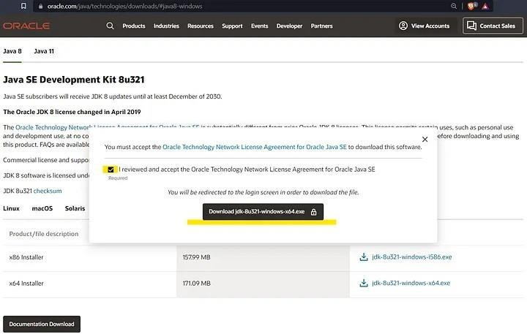

After that, you will be asked to sign in with your Oracle account and then the installer download will start immediately:

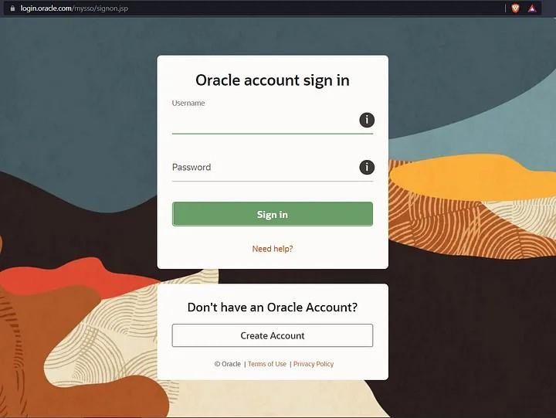

Java Installation

Then, you must proceed with the Java installation. Just open the folder where installer is in and run it:

Next, the installation wizard will be shown, click on Next in the following two views:

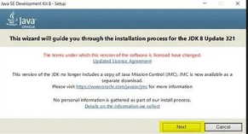

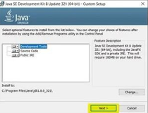

The third view is to select the destination folder where SDK files will be stored. Here,

you need to create the folder “Java” in the root path of your storage drive

1.- Select Change:

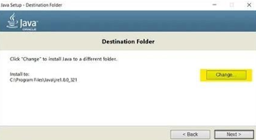

2.- In the Browse for Folder window, select your storage drive (In my case, the C: drive), click on Make New Folder button and assign the name “Java” to the new directory, then click OK:

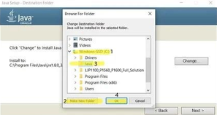

After that, you need to check if the destination folder has been updated. Once you have verified it, click on Next > and wait the installation to finish:

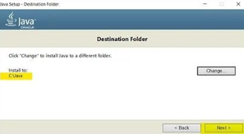

When this view displays, the installation has been finished and you can close the wizard:

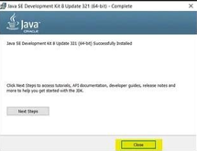

After this, you will see that there are two folders named “Java” the one you’ve just created and the other one will be inside the “Program Files” folder in your storage drive, the latter was created by the Java Installation Wizard:

You need to move the content of the folder created by the wizard

( C:\Program Files\Java ) to the Java folder you have created ( C:\Java ) to

avoid problems latter when you configure the environment variables:

After that, C:\Program Files\Java folder will be empty:

Then, you need to remove C:\Program Files\Java . As you can see, this folder no longer exists:

Java Environment Variable Configuration

Now, you need to create an environment variable for Java. To do so, type “Edit the system environment variables” in the Windows search bar and select that option:

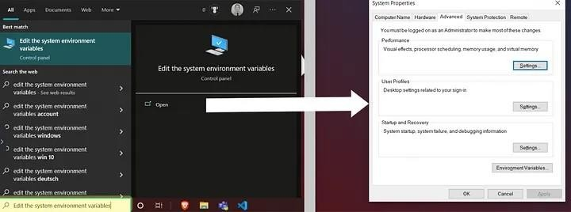

In the “System properties” view click on Environment Variables to open that

window:

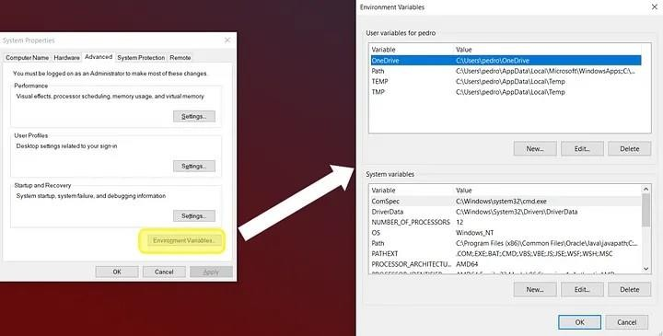

Now, in the “Environment Variables” window click on the New… button of the “User variables for <username>” panel. After that, “New User Variable” window will appear; there, you have to create the JAVA_HOME variable. In the Variable value field you need to write the path of the bin directory which is inside of the jdk folder.

Recall that jdk folder is located inside of the Java folder you previously created in the root of your storage drive. In my case I had to write C:\Java\jdk1.8.0_321\bin :

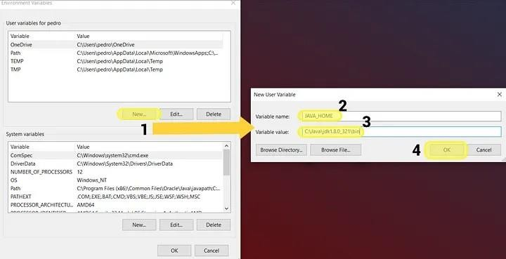

When you click on OK, the previous window will close and you can see the new variable at the top of the User variables for <username> list:

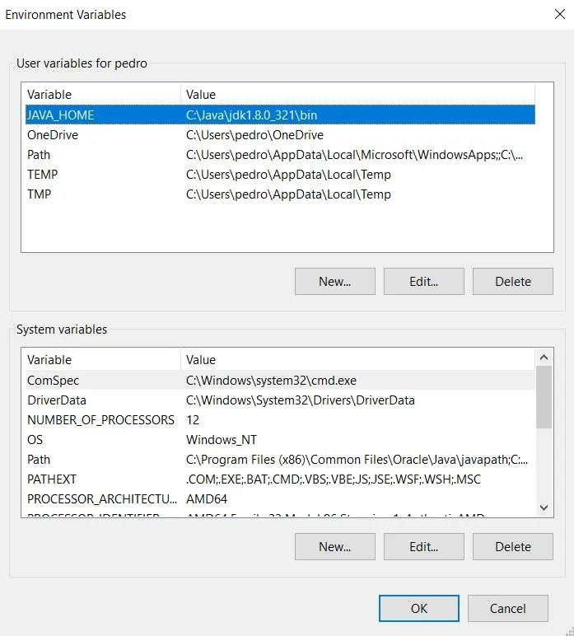

Now, in the System variables panel, find the Path variable, select it and click on Edit... to open the Edit environment variable window:

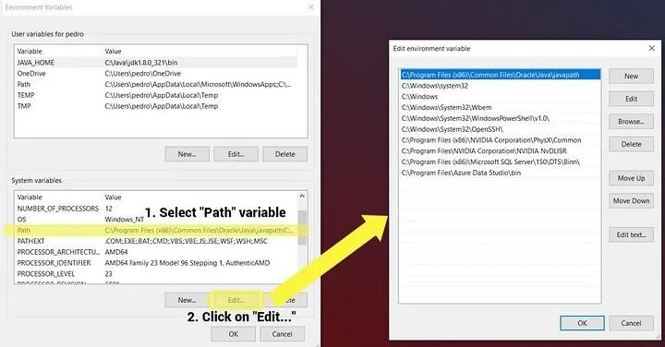

In the Edit environment variable window, click on New and write the path to the jdk folder, the exact same path you’ve just assign to the JAVA_HOME user variable. Then, click on OK:

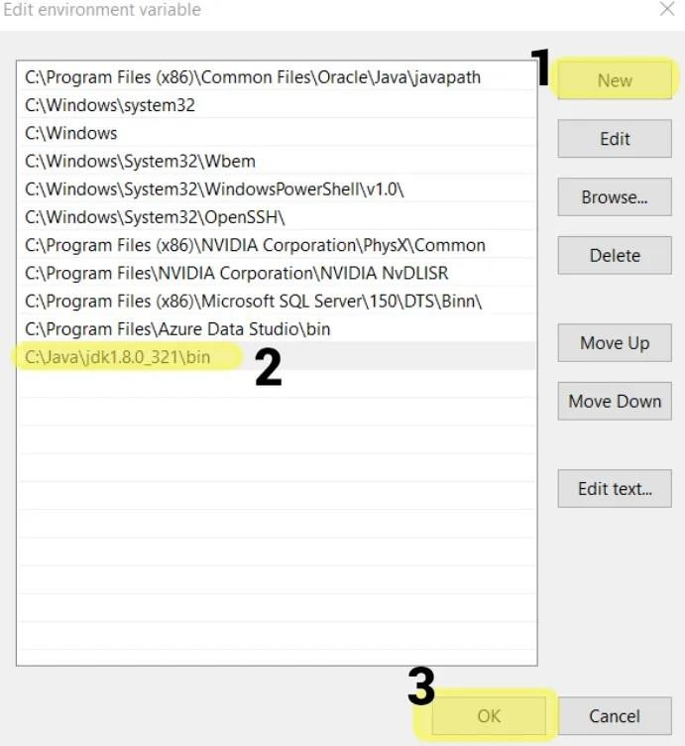

Now, be careful and click on OK in all windows related to the environment variables to save the changes; otherwise, you will need to repeat this process again.

Java Installation Verification

To check if Java was correctly installed, open the Windows Command Prompt. You can do this typing Command Prompt in the Windows search bar:

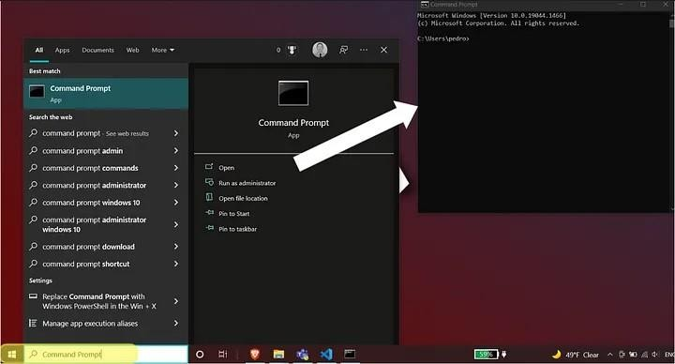

In the command prompt write javac and hit Enter. If you see this output, then Java is working properly:

Now, you can check the installed Java version typing java -version :

If you have had no problems, congratulations! that means you have installed Java successfully on your computer.

Hadoop File System Configuration

Hadoop Download

Once Java is working properly, you need to download and configure Hadoop File System. To

do so, go to [Hadoop official downloads site:](https://hadoop.apache.org/releases.html)

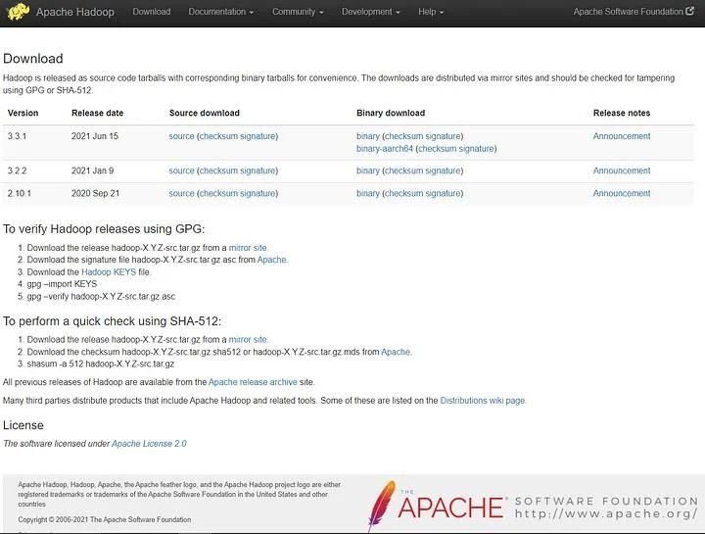

Once there, you need to download the latest stable version, how do we know which is this? For example, in the previous image latest version is 3.3.1, but

latest stable version is the immediate previous version, which is the 3.2.2, click on binary in the Binary download column:

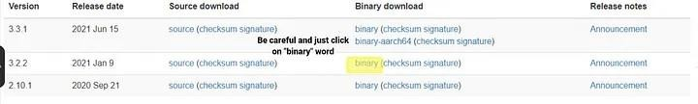

You will be redirected to another site from where you can download a

.tar.gz file corresponding to the selected Hadoop version. To start the download just click in the first link:

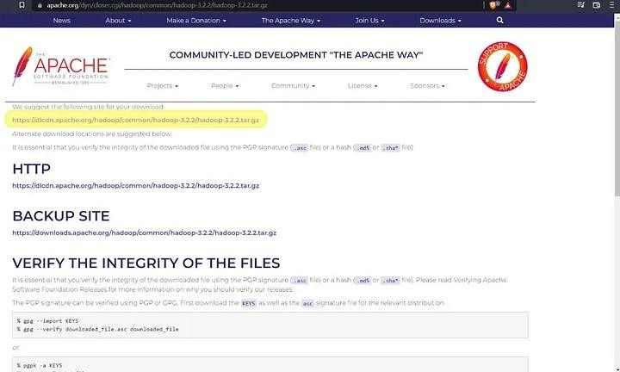

Hadoop Extraction

Once you have the .tar.gz file locally, extract it directly in the root of your storage drive (the same folder where you

have previously created Java directory) with WinRAR

Extract files... option. If you don't do it this way (i.e. extract it on the current folder and after that move the result manually) you may encounter with [Destination](https://answers.microsoft.com/en-us/windows/forum/all/destination-path-too-long-fix-when-movingcopying-a/3b501b04-2179-438b-af23-38da86d0bb5b) [Path Too Long error](https://answers.microsoft.com/en-us/windows/forum/all/destination-path-too-long-fix-when-movingcopying-a/3b501b04-2179-438b-af23-38da86d0bb5b) as I did:

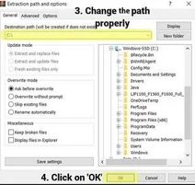

Just before extraction finishes, some error messages may be shown. If this occurs,

don’t worry, just ignore them clicking on Close:

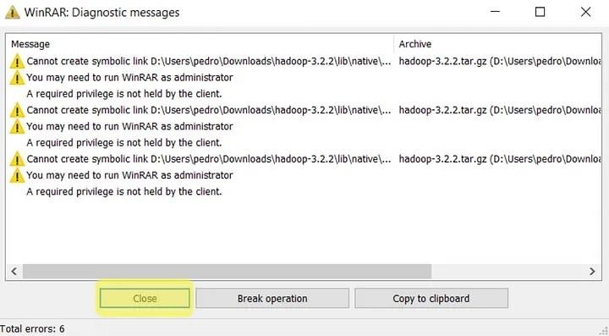

Now, you have Java and Hadoop folders in the same location:

Hadoop Configuration

Now, you need to configure some Hadoop files. If you have downloaded the same Hadoop version as me, then you need to go to etc\hadoop folder within the previously

extracted Hadoop directory (in my case, the complete path is C:\hadoop- 3.2.2\etc\hadoop ). Once there, open the following five files with your preferred text editor:

core-site.xml hadoop-

env.cmd hdfs-site.xml

mapred-site.xml yarn-

site.xml

In the core-site.xml you need to set the default Hadoop File System location. Paste this chunk of code inside <configuration> tag:

<property>

<name>fs.defaultFS</name>

<value>hdfs://localhost:9000</value>

</property>

In the hadoop-env.cmd file you need to provide the path to Java. This path was previously used when you set the JAVA_HOME environment variable. In my case, I set the JAVA_HOME value to : C:\Java\jdk1.8.0_321\bin ; but now, \bin folder must be

removed from the path, i.e. I had to use C:\Java\jdk1.8.0_321 path. You need to assign this path as JAVA_HOME value around line 25:

Before you edit hdfs-site.xml file, you need to create some new folders.

Go to Hadoop main directory in the root of your storage drive and create data folder inside of it:

Now, create the datanode and namenode folders inside the new data directory:

As you can see, datanode folder has the path C:\hadoop-3.2.2\data\datanode and namenode directory path is C:\hadoop-3.2.2\data\namenode

Once this is done, you need to provide this folders paths as properties in the hdfs- site.xml file. You can copy the following chunk directly into

<configuration> tag, just be careful to adjust the datanode and namenode paths according to your machine locations:

<property>

<name>dfs.replication</name>

<value>1</value>

</property>

<property>

<name>dfs.namenode.name.dir</name>

<value>C:\hadoop-3.2.2\data\namenode</value>

</property>

<property>

<name>dfs.datanode.data.dir</name>

<value>C:\hadoop-3.2.2\data\datanode</value>

</property>

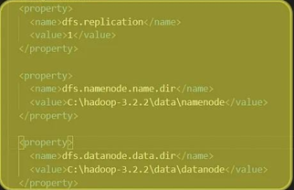

In the mapred-site.xml file you need to set yarn as the MapReduce framework. Copy the following code inside <configuration> tag:

<property>

<name>mapreduce.framework.name</name>

<value>yarn</value>

</property>

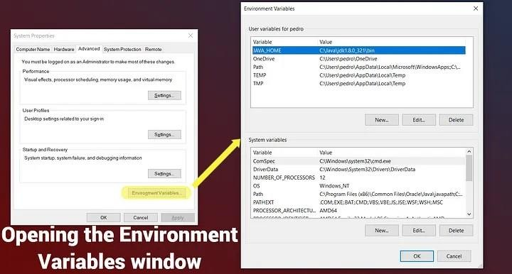

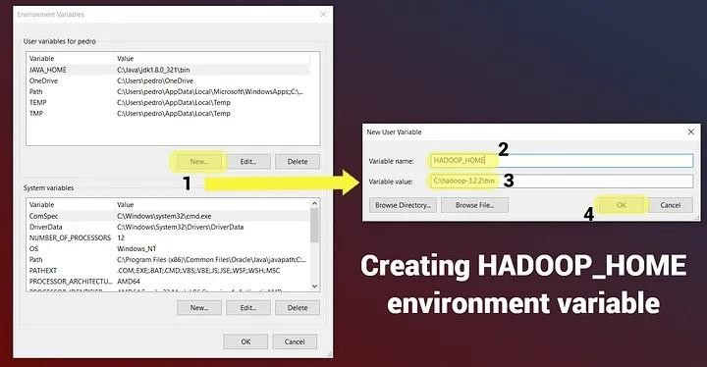

Now, you need to edit the Path system variable to add paths to bin and sbin folders of Hadoop. Both folders are in the root directoryof Hadoop.

So, bin path is the same you've just assigned to HADOOP_HOME variable

( C:\hadoop-3.2.2\bin ); sbin path, in my case will be C:\hadoop-3.2.2\sbin :

Once done, be careful and click on OK in all windows related to the environment variables to save the changes; otherwise, you will need to repeat this process again.

Fix of Hadoop ‘bin’ Folder

Now, you need to fix some configuration files. To do it, you need to replace the Hadoop bin folder with another bin folder which already contains all the files properly configured. First, download this compressed file [(hadoop3_xFixedbin.rar).](https://drive.google.com/file/d/1nCN_jK7EJF2DmPUUxgOggnvJ6k6tksYz/view?usp=sharing) Then, you need to delete bin folder:

After that, you must decompress [hadoop3_xFixedbin.rar i](https://drive.google.com/file/d/1nCN_jK7EJF2DmPUUxgOggnvJ6k6tksYz/view?usp=sharing)n order to move the fixed

bin folder to the Hadoop root location:

Now, you can check the new and fixed bin folder is in Hadoop root:

You will see that several command prompts will open. If Hadoop is properly configured, then this four command prompts will remain open and running:



Congratulations, Hadoop is running

OPEN COMMAND PROMPT:

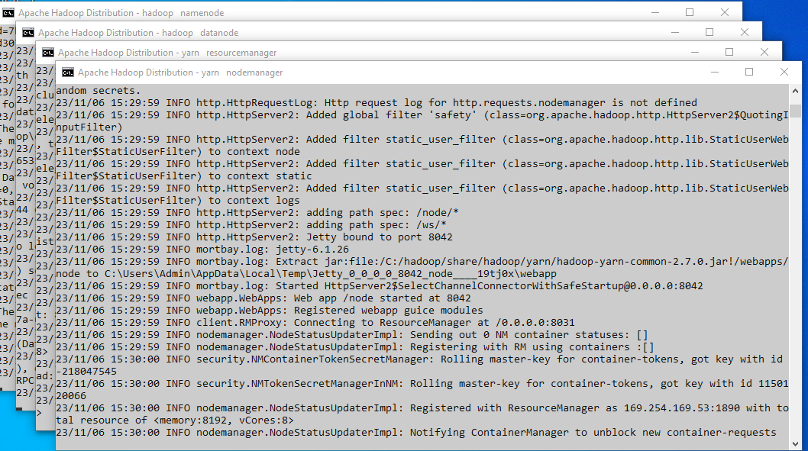

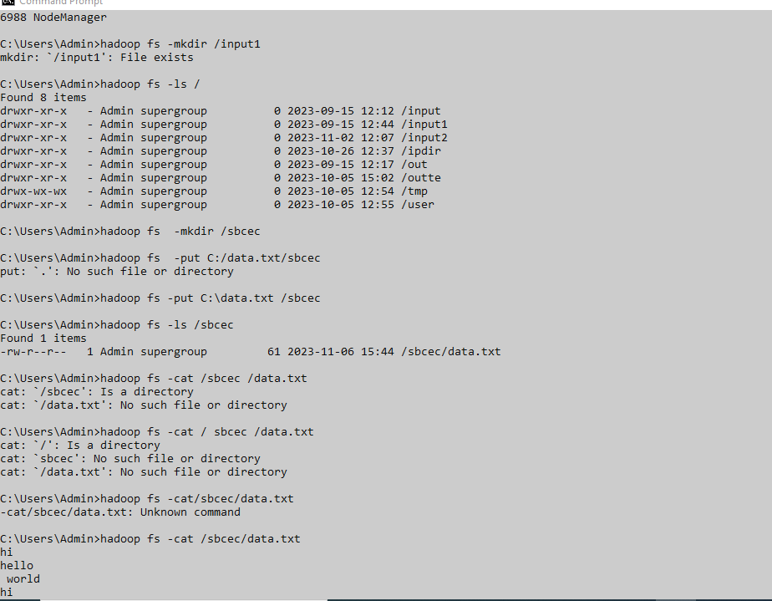

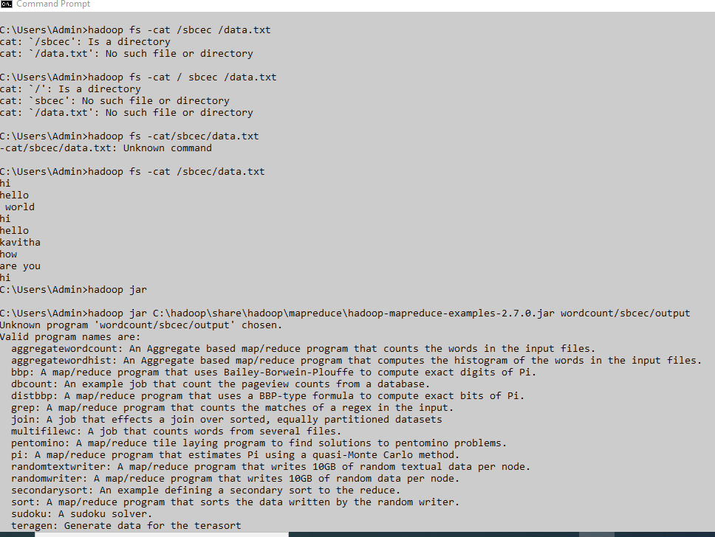

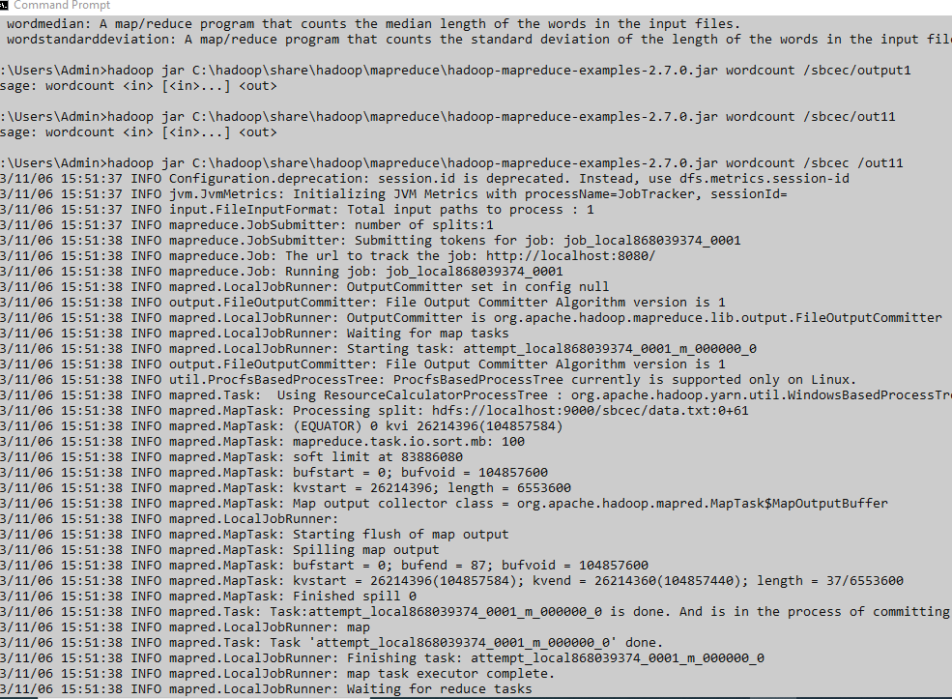

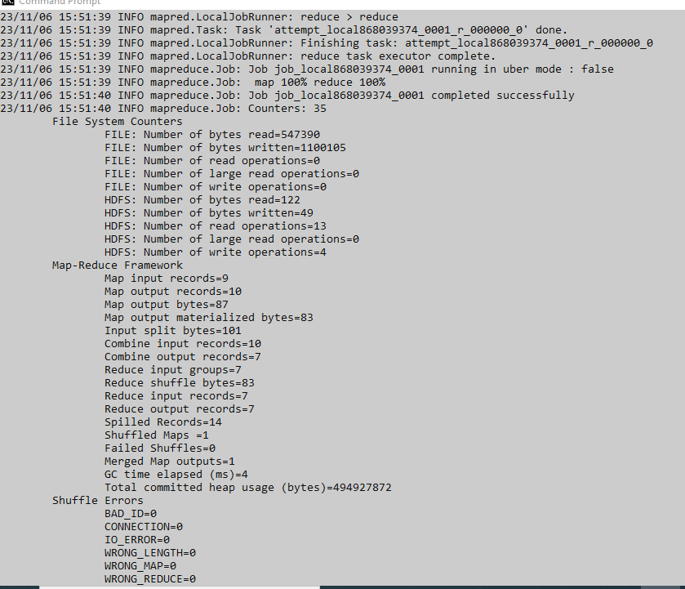

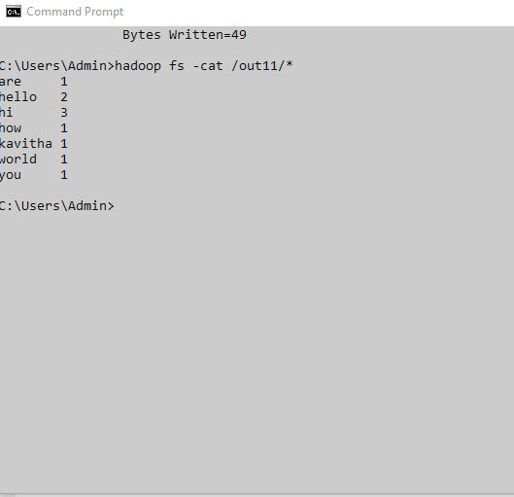

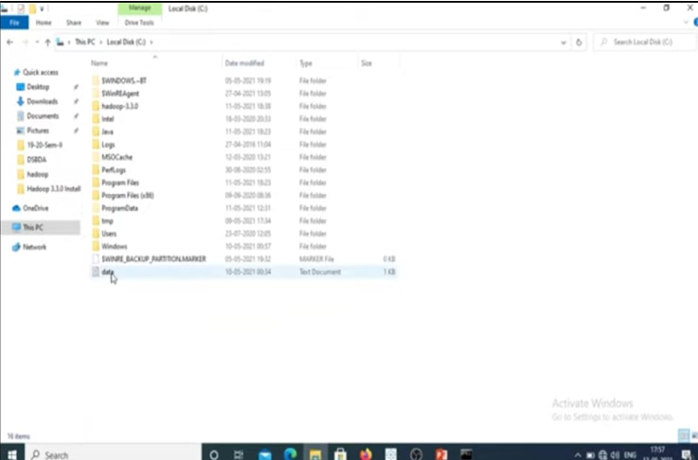



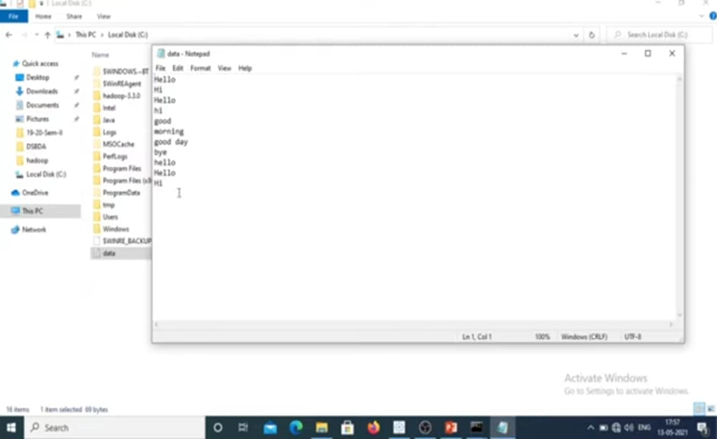

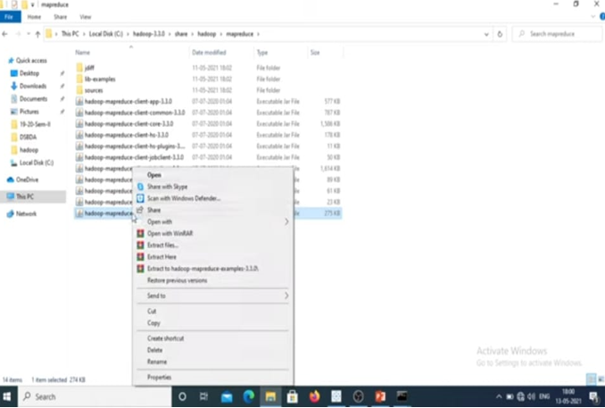

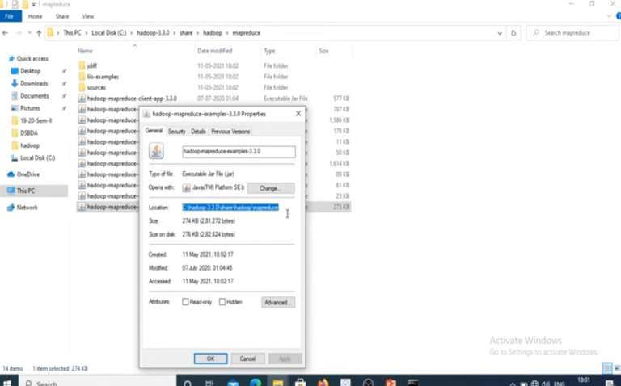

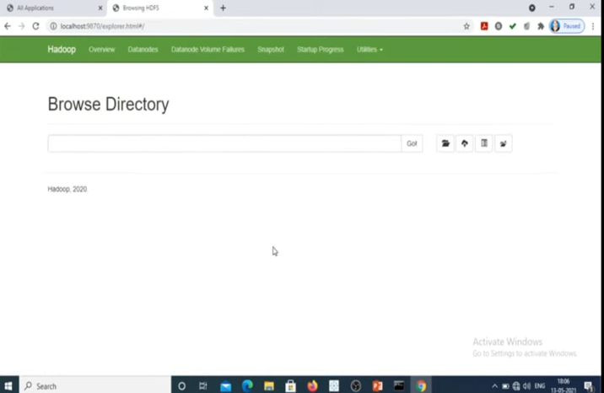

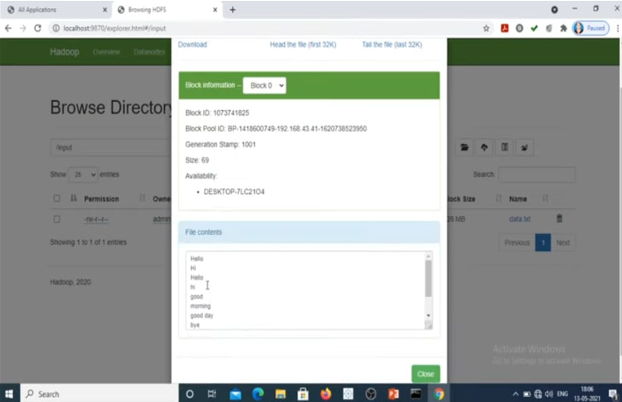

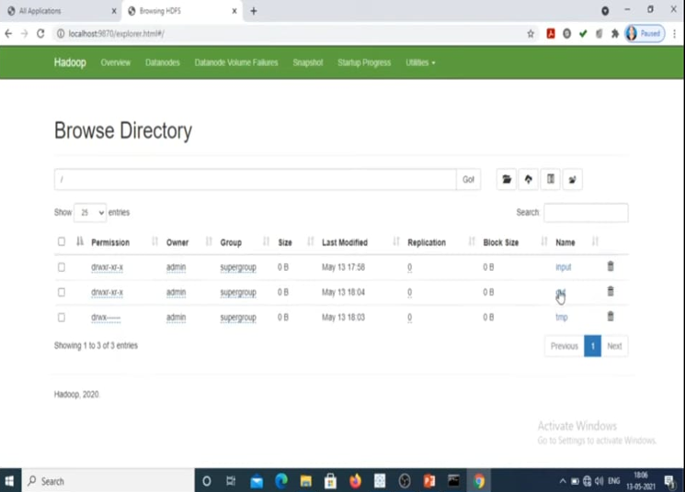

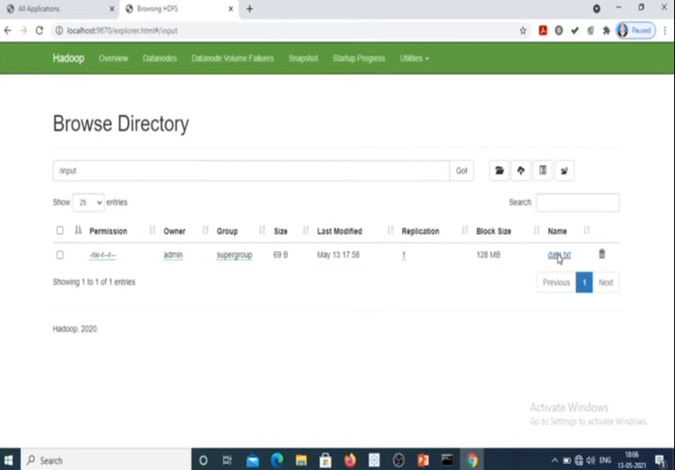

**Result:**

Thus Hadoop single node cluster was installed successfully and hence simple applications called wordcount was executed successfully.

|  |  |
| --- | --- |
| **EX NO: 8 , 9**    **DATE:** | **Creating and Executing Your First Container Using Docker.**  **Run a Container from Docker Hub.** |

**AIM:**

Creating and Executing Your First Container Using Docker.

Run a Container from Docker Hub.

Step 1: Install the docker using the below given link.

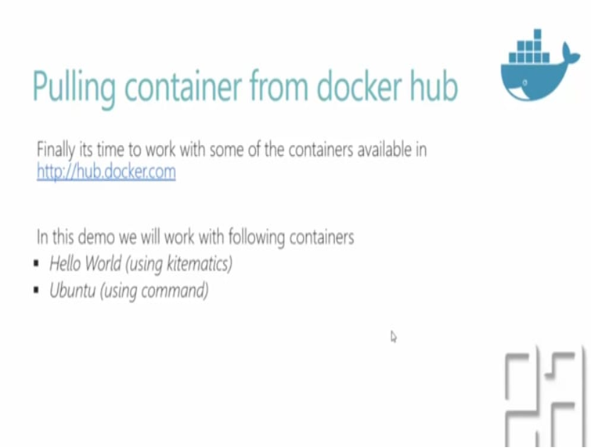

Step 2: Do the following :- cmds

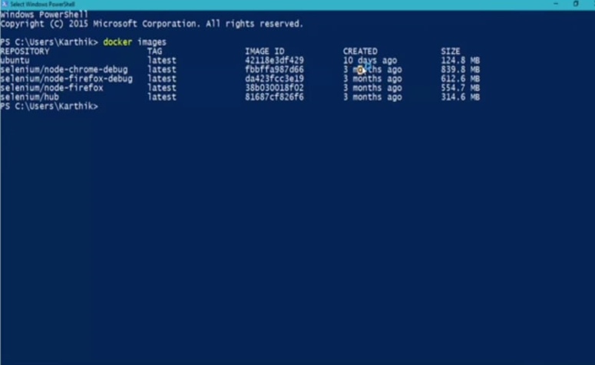

Step 3: the container that are already available will be showed along with its status at present.

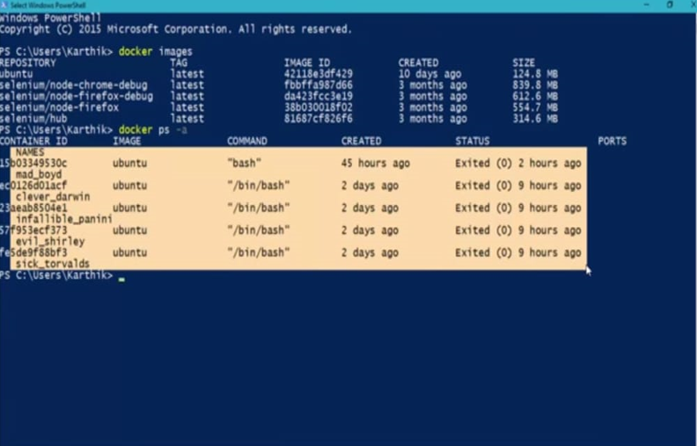

Step 4: for removing the already created containers the below cmd is used :- docker rmi ubuntu.

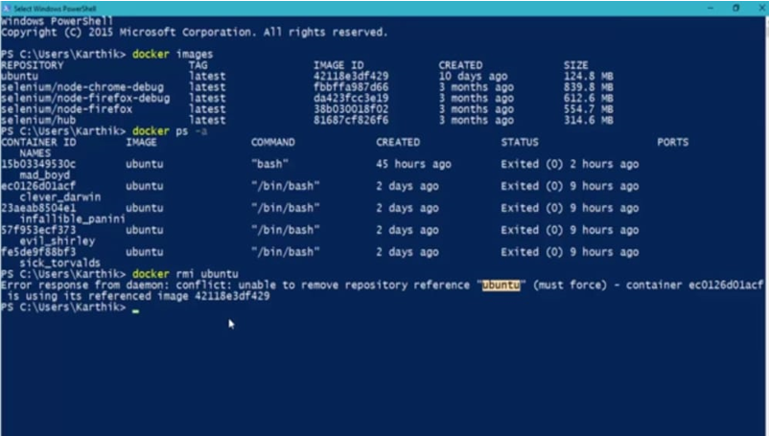

Step 5: It show’s the key words and its description

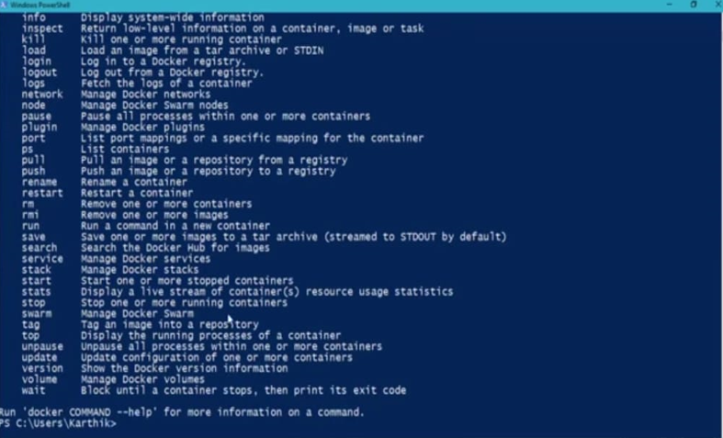

Step 6:do the cmd :- docker --help

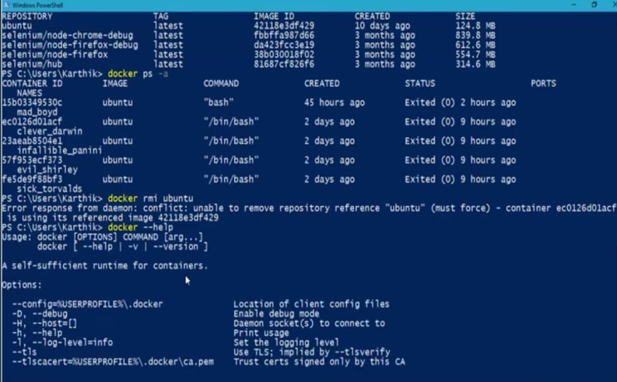

Step 7: These are the commands that are used to remove the files.

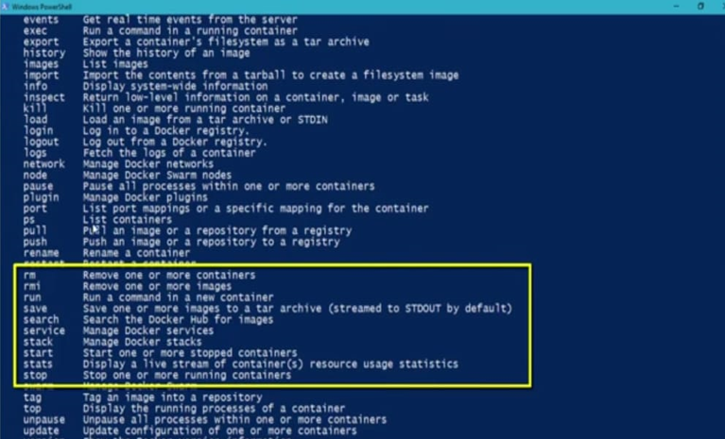

**Step 8: cmd:- docker ps -a**

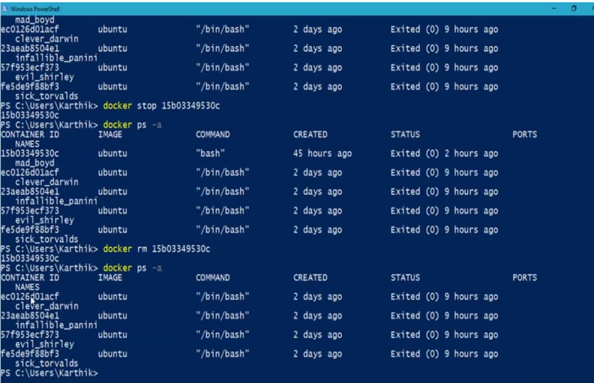

Step 9: The below are the cmmands used to delete a particular file containers.

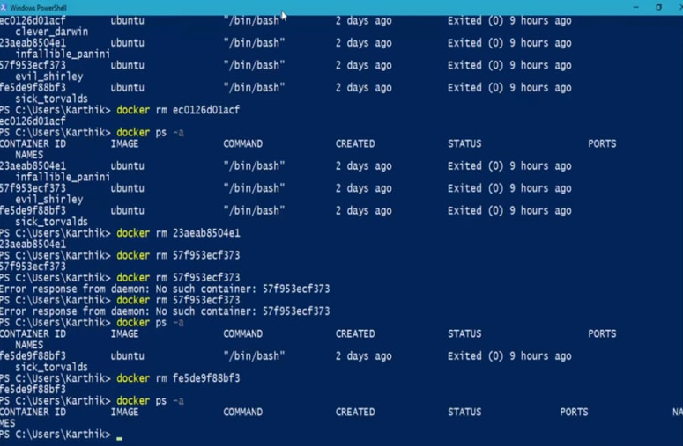

Step 10: to run: docker images cmd is used.

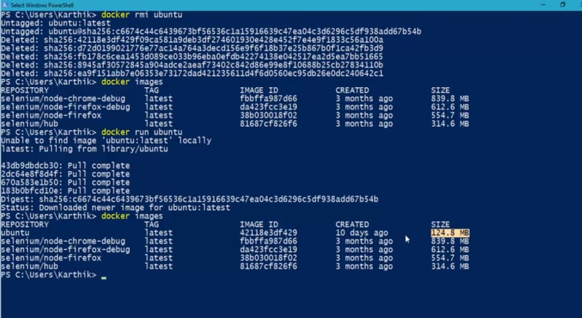

**Result:**

Thus the first container using docker was created and hence executed the container in docker hub was done successfully.